Task on Auto-Scaling Groups (ASG)

- Create one VPC in N. Virginia region.
Task Title
Create a Virtual Private Cloud (VPC) in the N. Virginia (us-east-1) region.
Objective
To create a dedicated virtual network environment that will host public and private subnets, EC2 instances, NAT gateway, and other AWS resources.
Prerequisites
Before creating the VPC, ensure you have:
• Region selected: N. Virginia (us-east-1)
• No overlapping CIDR with existing VPCs
Step-by-Step Implementation (With Evidence)
Step 1: Click “Create VPC” and Fill Required Details
Configure the VPC with the following values:
• Resource type: VPC Only
• Name tag: Production-VPC
• IPv4 CIDR block: 10.0.0.0/16
• Tenancy: Default
Explanation:
The CIDR block defines the IP range inside the VPC.
Evidence: (Screenshot of Create VPC form filled with above details)
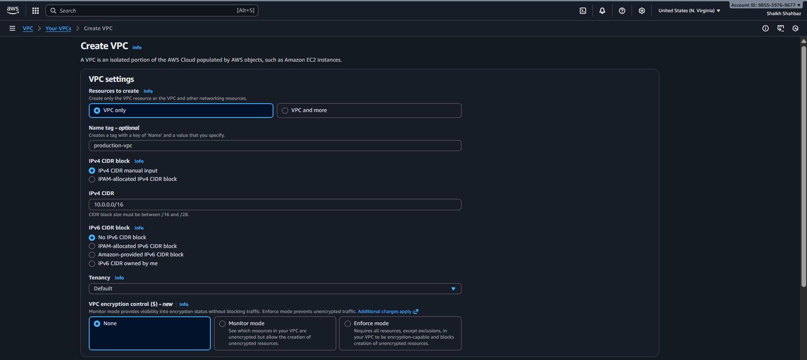
Step 2: Create the VPC
• Click the Create VPC button
• Wait for the success confirmation
Explanation:
AWS provisions the VPC with your defined IP range.
Evidence: (Screenshot of success message and VPC details)
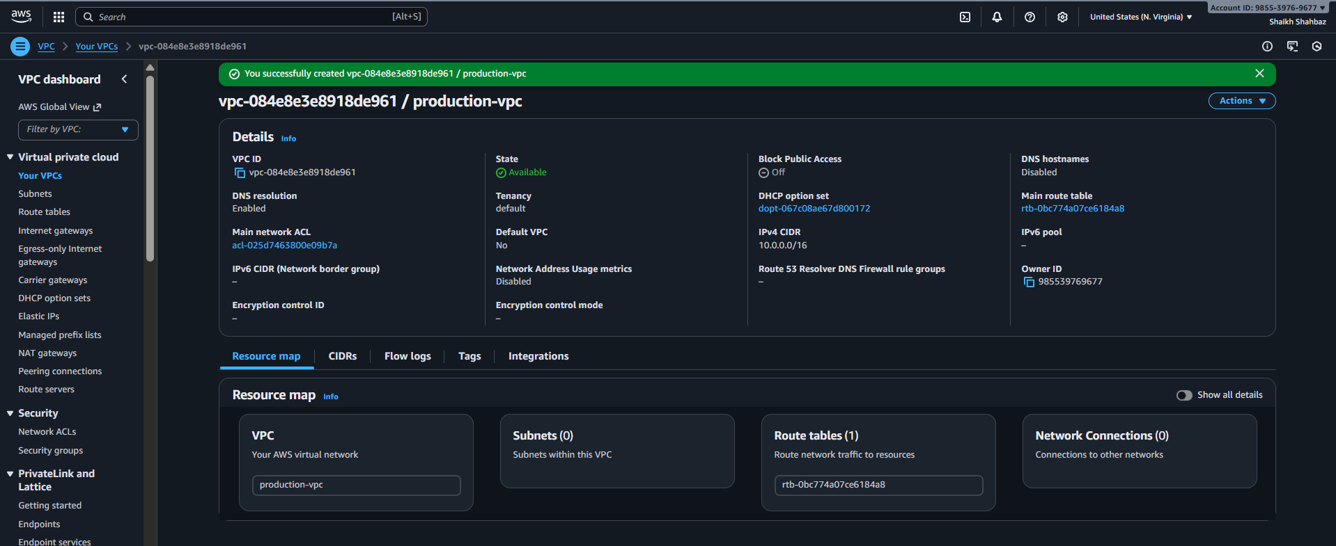
Validation Steps (With Evidence)
Validation 1: Resource Health
Check that the VPC is active.
• Path: VPC → Your VPCs
• Status should show “Available”
Evidence: VPC list screenshot showing Production-VPC
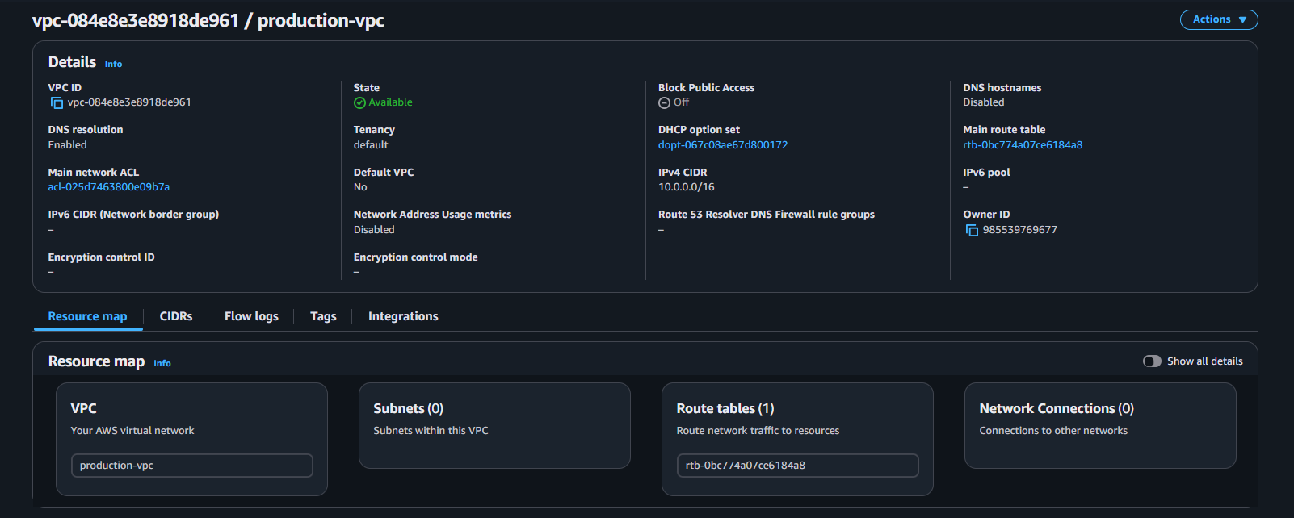
Issues Faced (Optional but Recommended)
No issues encountered.
Overlapping CIDR ranges may prevent VPC creation. Ensure uniqueness across your account.
Conclusion
The VPC has been successfully created in the N. Virginia region with IPv4 CIDR 10.0.0.0/16. This VPC will be used as the foundational network layer for public/private subnets, EC2 instances, NAT gateway, and load balancer deployment.

- Create two subnets: one public subnet and one private subnet.
Task Title
Create a public subnet and a private subnet inside the existing VPC.
Objective
To build the subnet architecture required for hosting public-facing resources (like NAT gateway, public EC2) and private internal resources (private EC2, backend services).
Prerequisites
• VPC (Production-VPC)
• Non-overlapping CIDR plan (e.g.)
– Public Subnet: 10.0.1.0/24
– Private Subnet: 10.0.2.0/24
• Region: N. Virginia (us-east-1)
Step-by-Step Implementation (With Evidence)
Step 1: Open Subnet Console
• Console path: AWS Console → VPC → Subnets
• Click Create subnet
Step 2: Create the Public Subnet
• Select VPC : Production-VPC
• Subnet name: Public-Subnet
• Availability Zone: us-east-1a
• IPv4 CIDR block: 10.0.1.0/24
Explanation:
This subnet will host the NAT gateway and the public EC2 instance.
Evidence: Screenshot of the public subnet creation form.
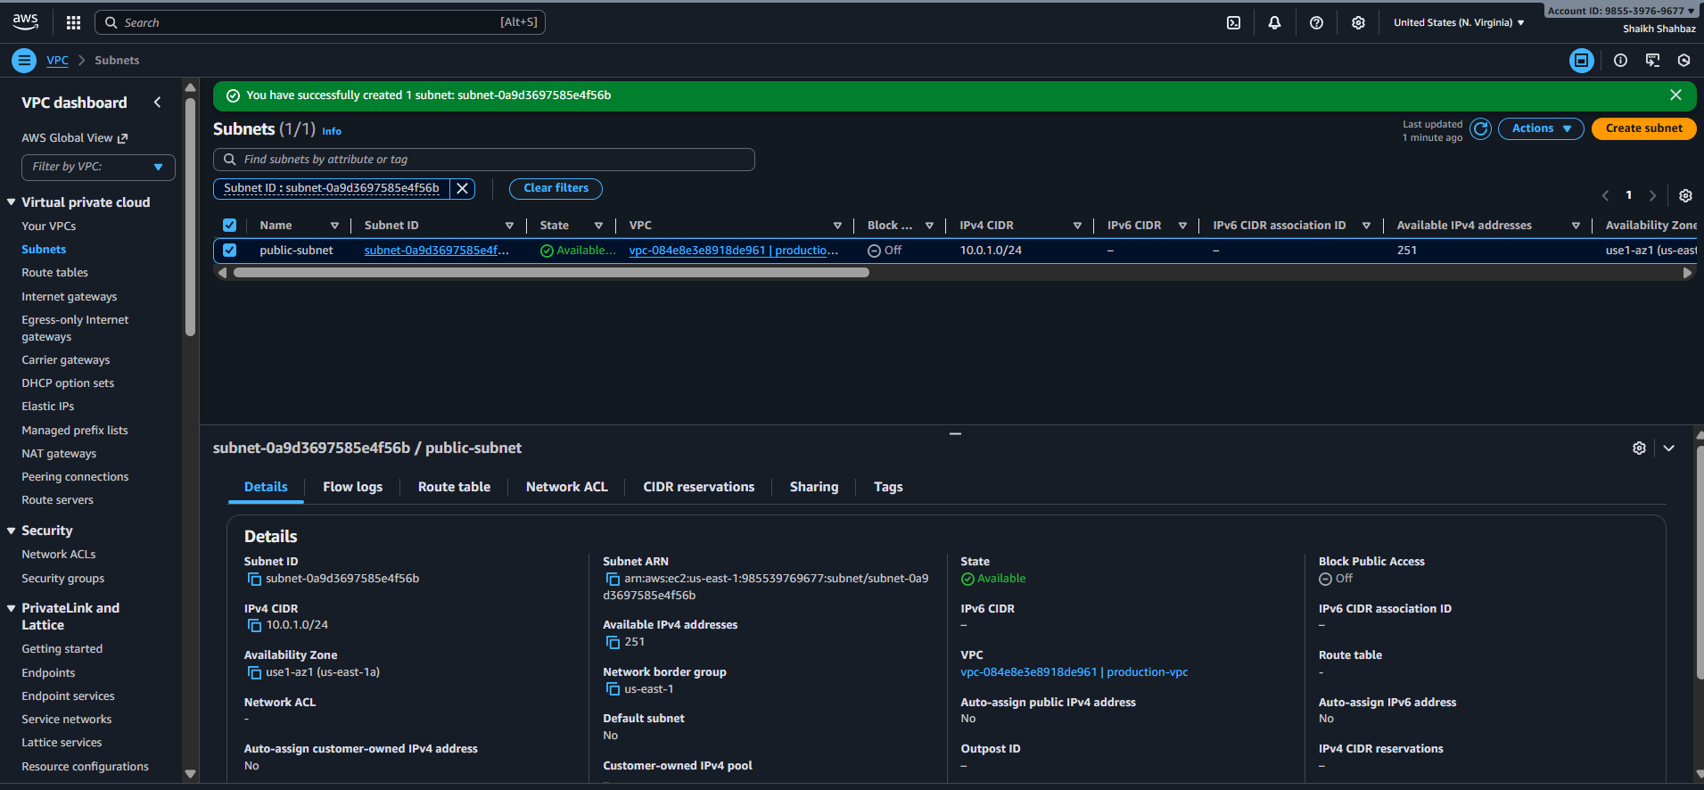
Step 3: Create the Private Subnet
Fill the form as:
• VPC ID: Production-VPC
• Subnet name: Private-Subnet
• Availability Zone: us-east-1b
• IPv4 CIDR block: 10.0.2.0/24
Explanation:
This subnet will host the internal EC2 instance and private workloads.
Evidence: Screenshot of the private subnet creation form
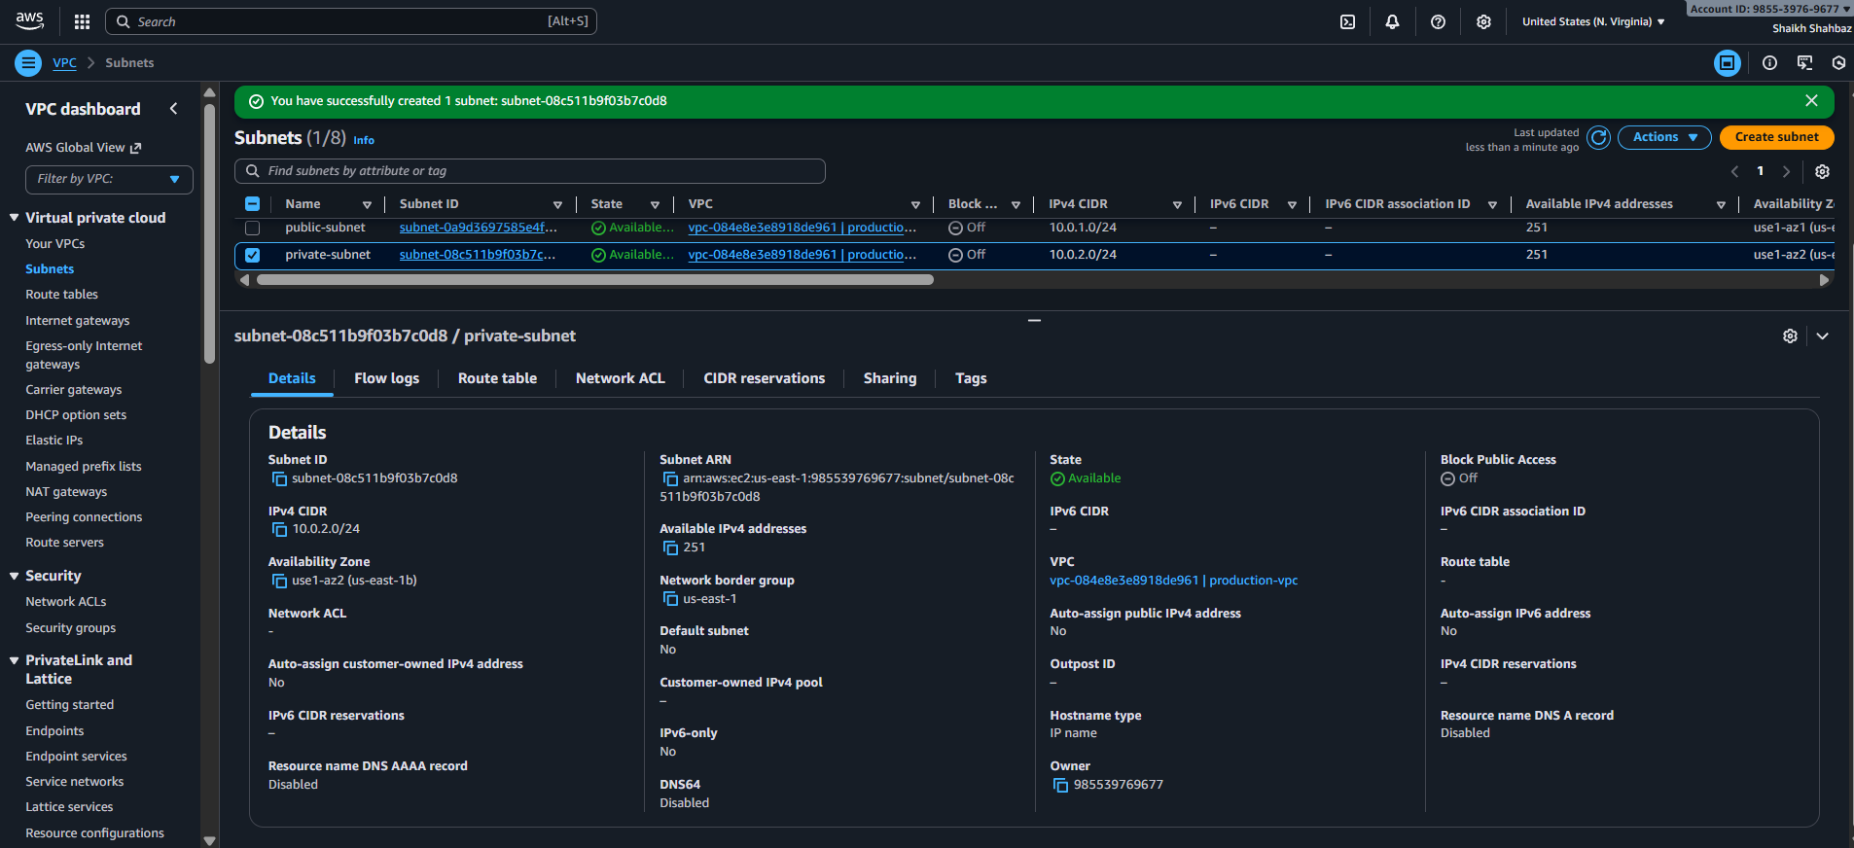
Step 4: Modify Auto-assign Public IP (Public Subnet Only)
• Select Public-Subnet → Actions → Edit subnet settings
• Enable: Auto-assign IPv4 public address
Explanation:
Instances in the public subnet must get a public IP automatically.
Evidence: Screenshot of Auto-assign public IP = Enabled.
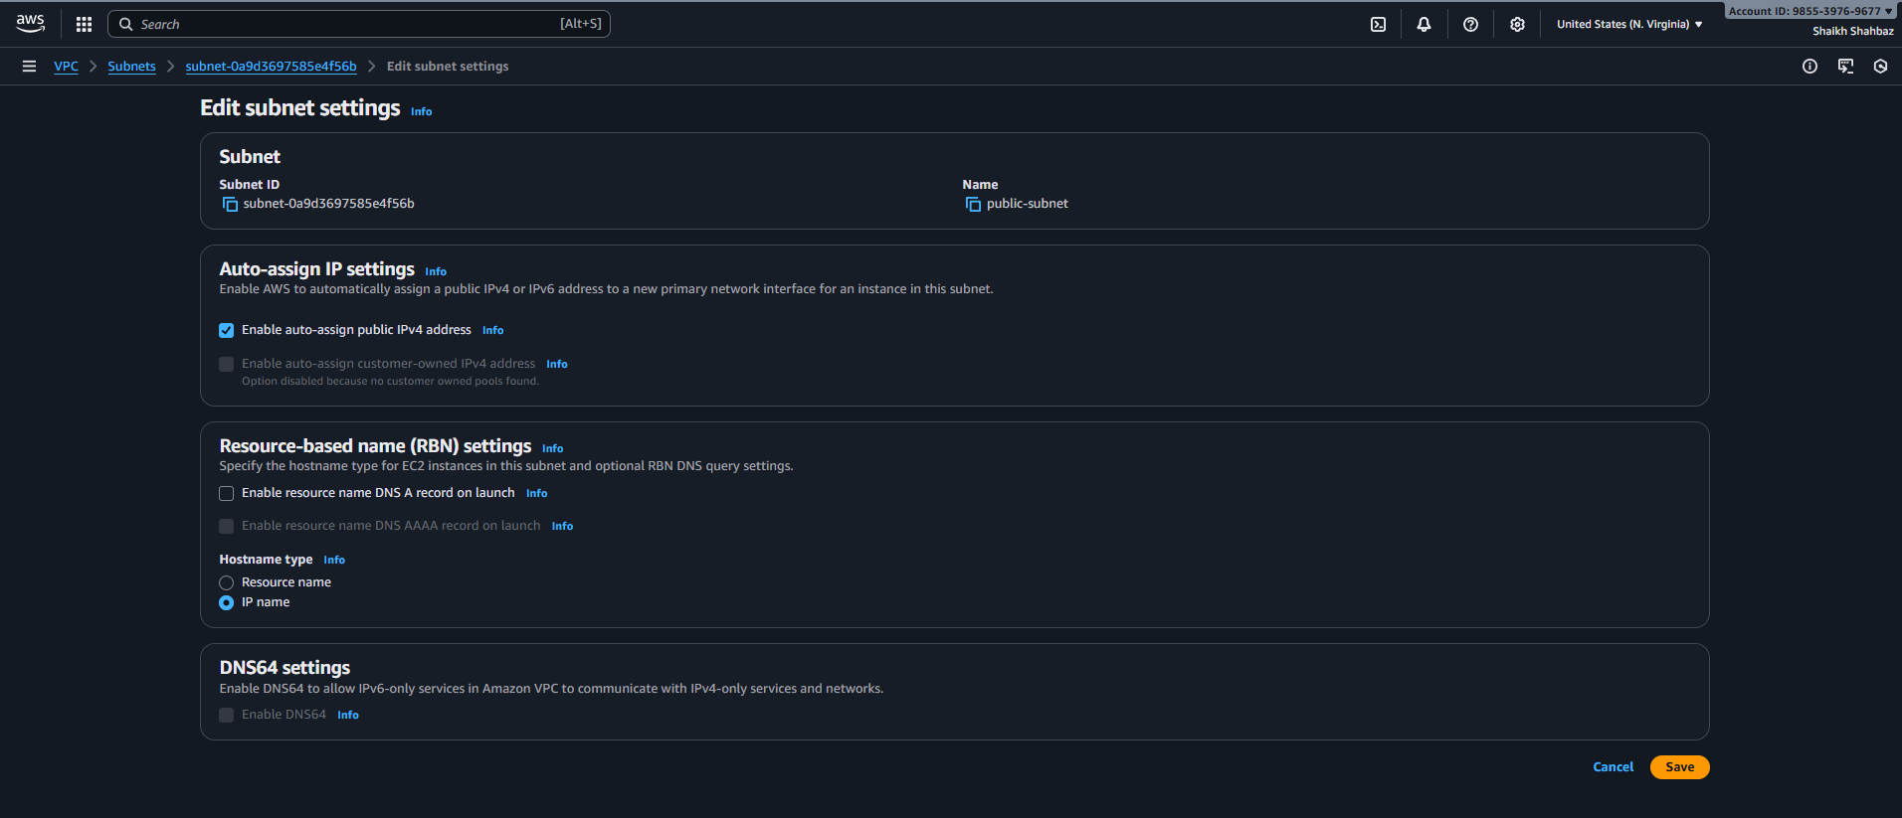
Validation Steps (With Evidence)
Validation 1: Resource Health
Verify both subnets exist.
• Go to VPC → Subnets
• Public-Subnet and Private-Subnet listed.
Evidence: Screenshot showing both subnets.
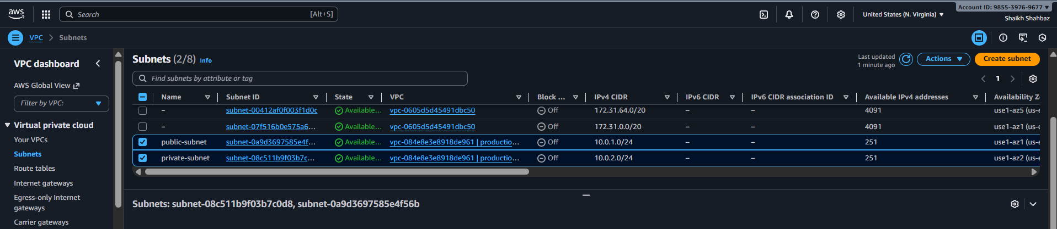
Issues Faced (Optional but Recommended)
Incorrect CIDR or overlapping ranges may block subnet creation.
Ensure 10.0.1.0/24 and 10.0.2.0/24 do not overlap with VPC CIDR or each other.
Conclusion
Two subnets were successfully created—one public and one private—with correct CIDR blocks, AZ placement, and public IP assignment settings. These subnets are now ready for IGW, NAT gateway, route tables, and EC2 deployments

- Attach an IGW to the VPC.
Task Title
Create and attach an Internet Gateway (IGW) to the existing VPC.
Objective
To enable internet connectivity for resources placed in the public subnet.
Prerequisites
• Existing VPC: Production-VPC
• Public subnet already created
• Region: N. Virginia (us-east-1)

Step-by-Step Implementation (With Evidence)
Open the Internet Gateway Console
• Console path: AWS Console → VPC → Internet Gateways
• Click Create internet gateway
Explanation:
An IGW provides a route for public internet connectivity.
Step 1: Create the Internet Gateway
Fill the details:
• Name: Production-IGW
Click Create Internet Gateway.
Explanation:
This creates a standalone IGW resource that can be attached to any VPC.
Evidence: Screenshot showing IGW successfully created.
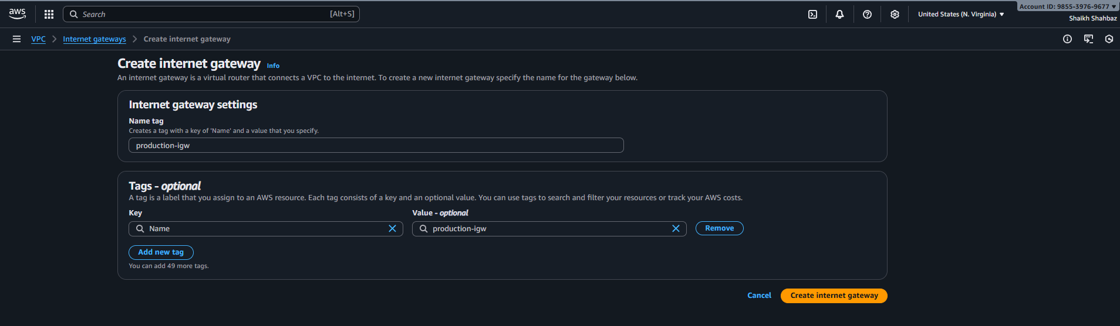
Step 2: Attach IGW to the VPC
• Select the newly created Production-IGW
• Click Actions → Attach to VPC
• Choose: Production-VPC
• Click Attach internet gateway
Explanation:
This links the IGW to your VPC so the public subnet can reach the internet.
Evidence: Screenshot showing IGW state = Attached, VPC ID visible.
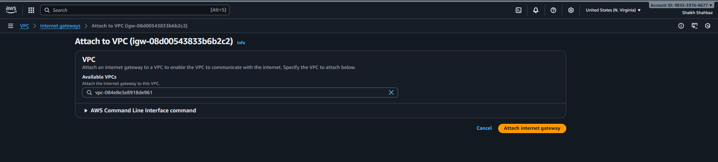
Validation Steps (With Evidence)
Validation 1: Resource Health
Check IGW status:
• Should show State: Attached
Evidence: IGW details screenshot.
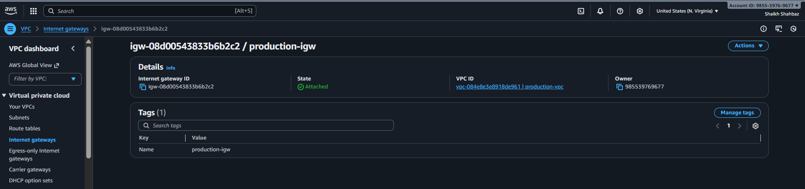
Issues Faced (Optional but Recommended)
Some accounts have quota limits or previously attached IGWs.
If IGW is already attached to another VPC, detach it first.
Conclusion
The Internet Gateway has been successfully created and attached to the Production-VPC. This allows the public subnet to connect to the internet once the route table is configured.

- Create one public route table (RT) and one private route table.
Task Title
Create and configure public and private route tables for proper network routing in the VPC.
Objective
To ensure the public subnet routes traffic to the Internet Gateway and the private subnet routes traffic through the NAT Gateway.
Prerequisites
• VPC: Production-VPC
• Public-Subnet (10.0.1.0/24)
• Private-Subnet (10.0.2.0/24)
• Internet Gateway attached (Production-IGW)
• Region: N. Virginia (us-east-1)
Step-by-Step Implementation (With Evidence)
Open the Route Tables Console
• Console path: AWS Console → VPC → Route Tables
• Click Create route table
Explanation:
Route tables define where network traffic should go.
Step 1: Create the Public Route Table
Configure:
• Name: Public-RT
• VPC: Production-VPC
Click Create route table.
Explanation:
This route table will later route traffic to the Internet Gateway.
Evidence: Screenshot showing Public-RT created.
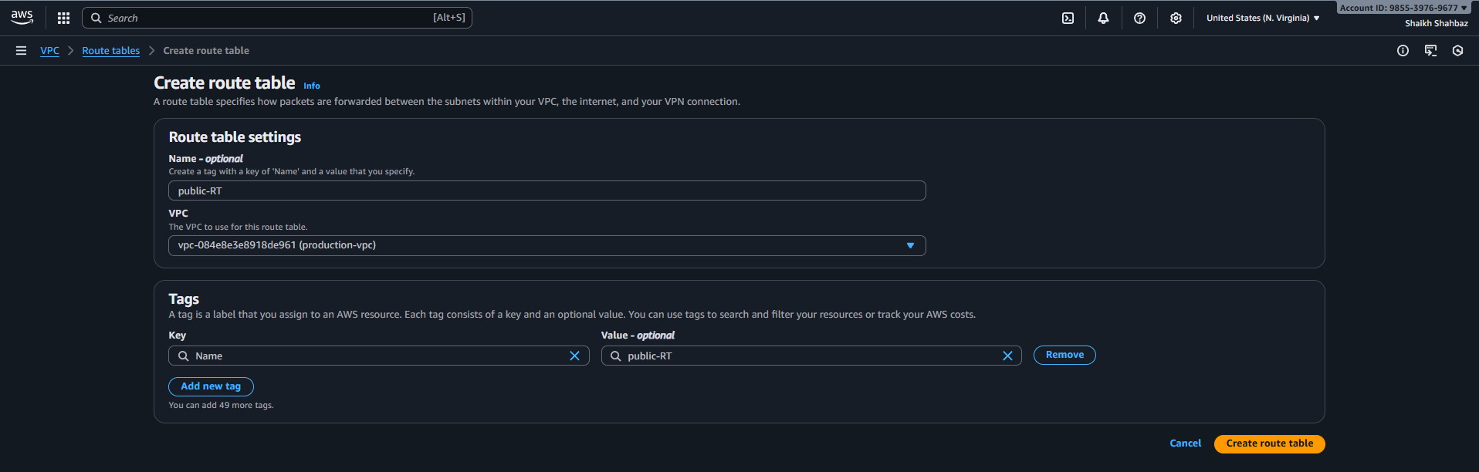
Step 2: Create the Private Route Table
Configure:
• Name: Private-RT
• VPC: Production-VPC
Click Create route table.
Explanation:
This route table will later route traffic through the NAT Gateway.
Evidence: Screenshot showing Private-RT created.
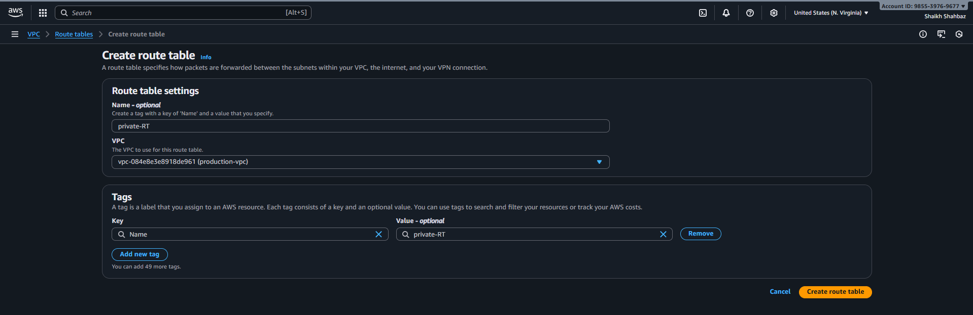
Step 3: Associate Public Subnet with Public Route Table
• Select Public-RT
• Go to Subnet associations
• Click Edit subnet associations
• Select: Public-Subnet (10.0.1.0/24)
• Save
Explanation:
Associating subnets tells AWS which route table they use.
Evidence: Screenshot of subnet association.
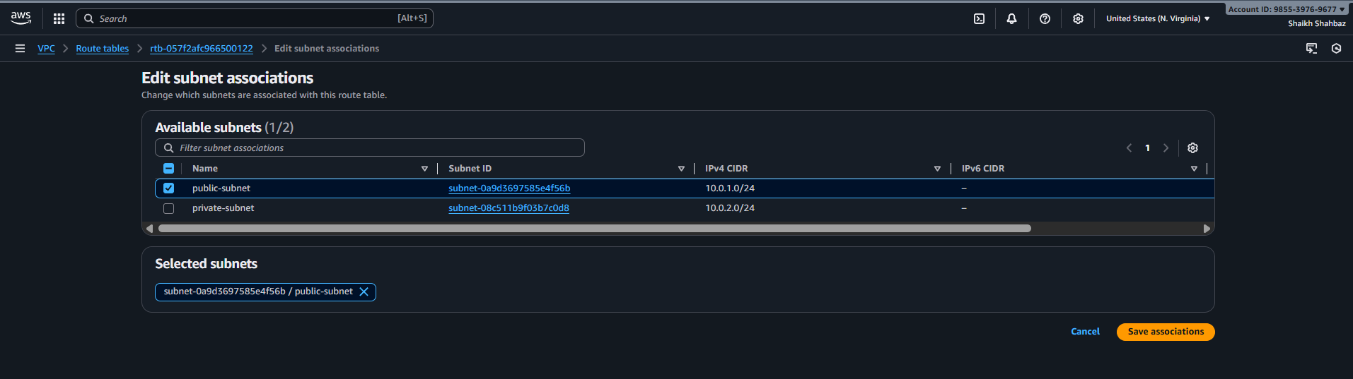
Step 4: Associate Private Subnet with Private Route Table
• Select Private-RT
• Subnet associations → Edit
• Select: Private-Subnet (10.0.2.0/24)
• Save
Explanation:
This ensures the private subnet uses the private route table.
Evidence: Screenshot of association.
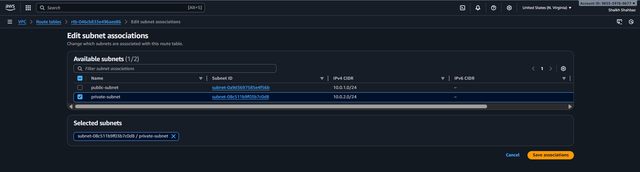
Step 5: Add IGW Route to Public Route Table
• Select Public-RT → Routes → Edit routes
• Add route:
– Destination: 0.0.0.0/0
– Target: Internet Gateway (Production-IGW)
• Save
Explanation:
This allows public subnet traffic to reach the internet.
Evidence: Screenshot showing IGW route.
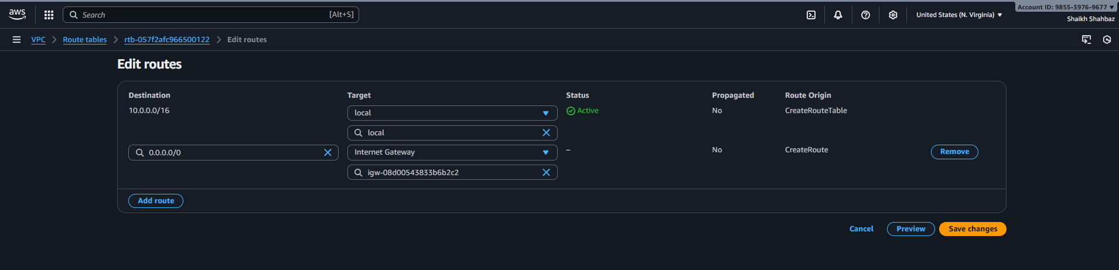
Validation Steps (With Evidence)
Validation 1: Resource Health
Public-RT and Private-RT should exist and be associated with correct VPC.
Evidence: Route table list screenshot.
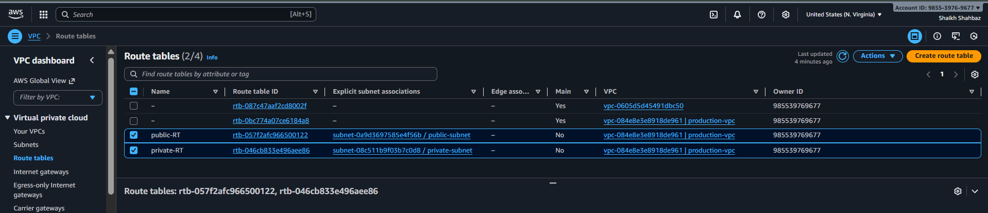
Validation 2: Functional Check
Public-RT should show:
• 0.0.0.0/0 → igw-xxxx
Evidence: Screenshot of route entry.
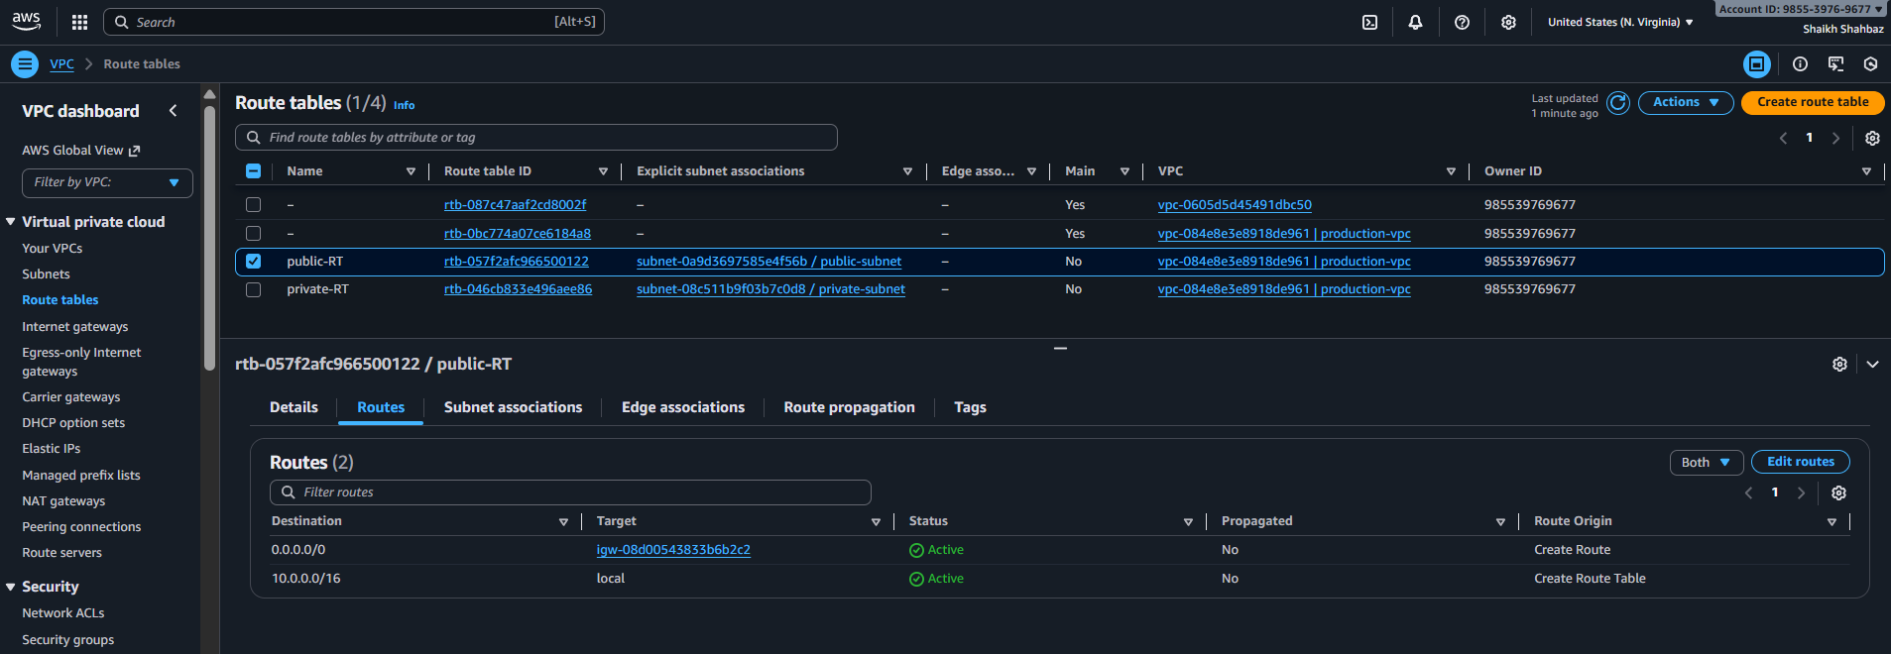
Issues Faced (Optional but Recommended)
New users often forget to add the IGW route in the public RT.
Always confirm the 0.0.0.0/0 route exists.
Conclusion
Public and private route tables are successfully created and associated with their respective subnets. Public subnet routes traffic to the Internet Gateway, and the private subnet is ready for NAT Gateway integration.

- Deploy a NAT gateway in the public subnet and attach the NAT gateway to the private subnet.
Task Title
Create a NAT Gateway in the public subnet and configure the private route table to route outbound traffic through it.
Objective
Allow private subnet instances to access the internet for updates and package installations without exposing them to inbound public traffic.
Prerequisites
• VPC: Production-VPC
• Public-Subnet (10.0.1.0/24)
• Private-Subnet (10.0.2.0/24)
• Public Route Table
• Private Route Table
• Internet Gateway attached
• Region: N. Virginia (us-east-1)
Step-by-Step Implementation (With Evidence)
Step 1: Open NAT Gateway Console
• Console path: AWS Console → VPC → NAT Gateways
• Click Create NAT Gateway
Explanation:
NAT Gateway provides outbound-only internet access for private subnets.
Step 2: Configure NAT Gateway
Settings:
• Name: Production-NATGW
• Subnet: Public-Subnet (10.0.1.0/24)
• Connectivity Type: Public
• Elastic IP: Allocate new EIP → Select
Click Create NAT Gateway.
Explanation:
NAT must be placed in a public subnet so it can access the internet.
Evidence: Screenshot showing NAT gateway creation details and EIP allocation.
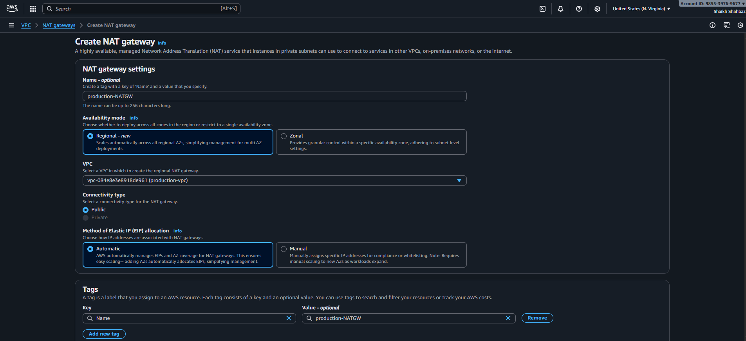
Step 3: Update Private Route Table to Use the NAT Gateway
• Go to VPC → Route Tables
• Select: Private-RT
• Routes → Edit routes
• Add:
– Destination: 0.0.0.0/0
– Target: NAT Gateway (nat-xxxxxxxx)
• Save changes
Explanation:
Private subnet traffic will now go through the NAT Gateway instead of IGW.
Evidence: Screenshot of route table with NAT Gateway entry.
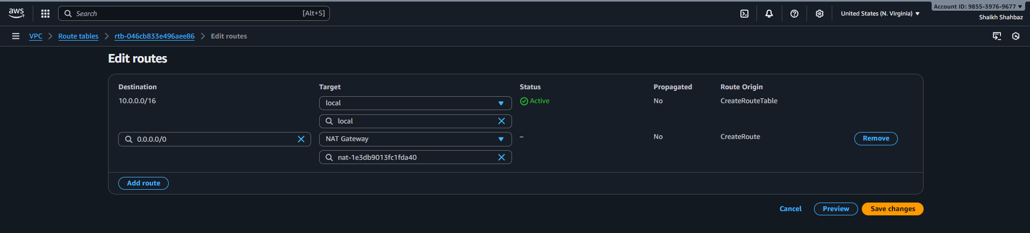
Validation Steps (With Evidence)
Validation 1: Resource Health
NAT Gateway status should show Available.
Evidence: Screenshot of NATGW state = Available.
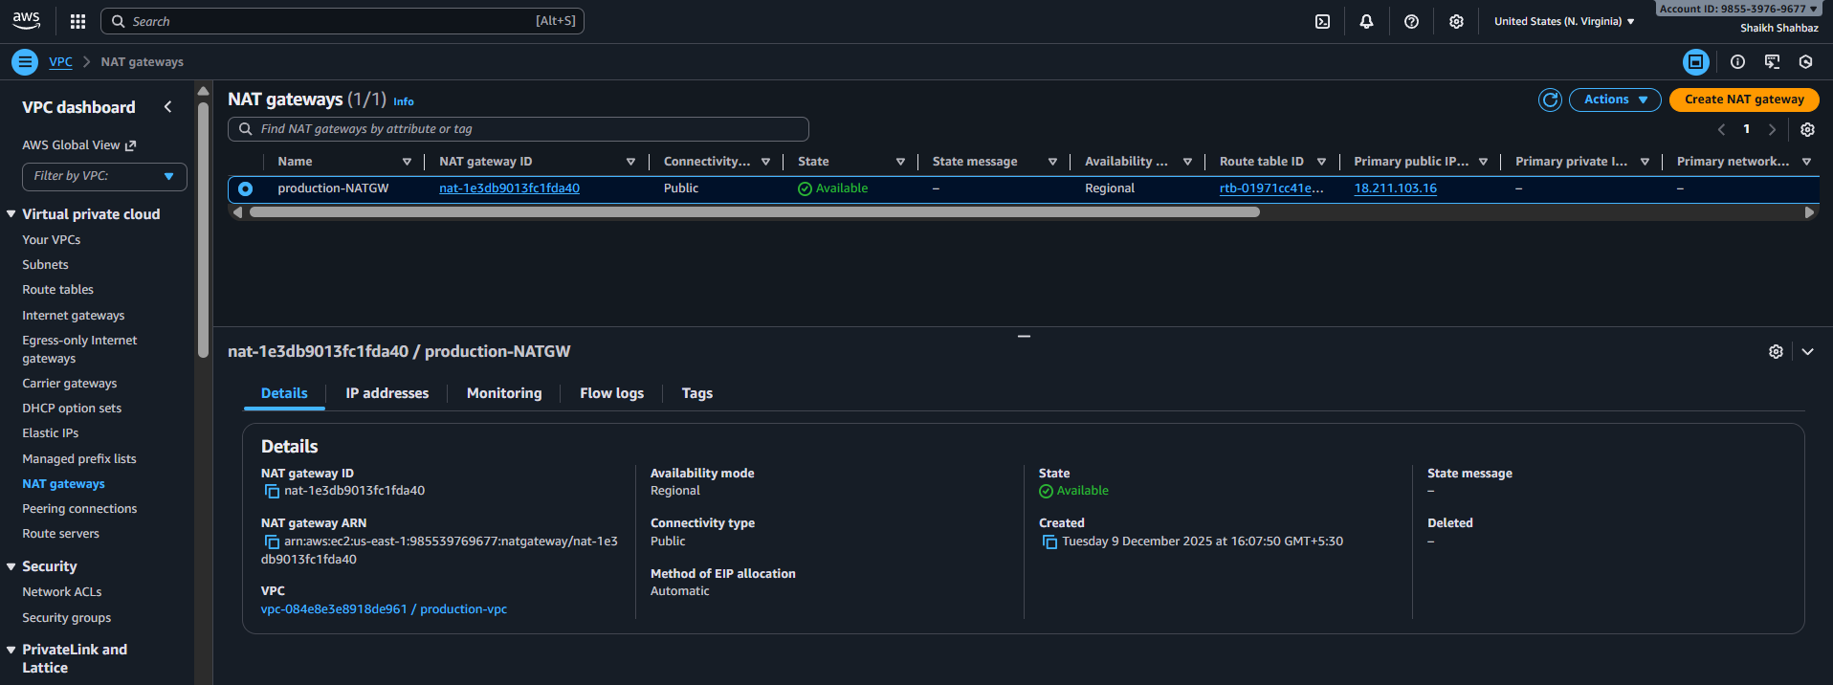
Validation 2: Network Check
Check routing:
• Private-RT → 0.0.0.0/0 → nat-xxxx
• Public-RT should still point to IGW.
Evidence: Screenshots of both route tables.
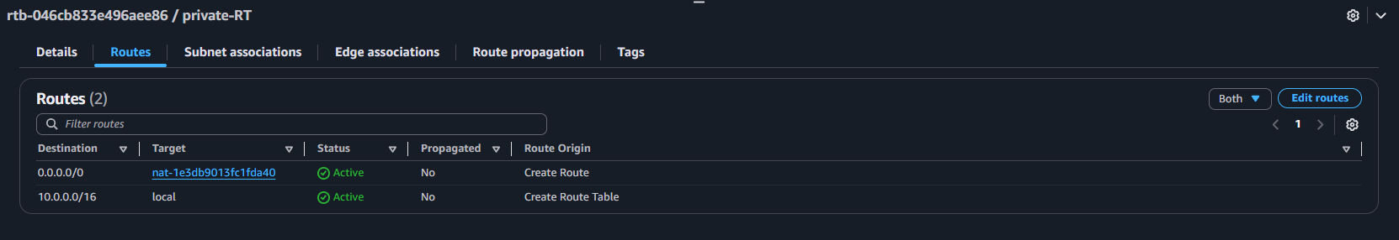
Issues Faced (Optional but Recommended)
• NAT Gateway must be in a public subnet.
• If IGW is not attached, NATGW will stay in “Failed” status.
Conclusion
The NAT Gateway has been successfully created in the public subnet and configured in the private route table. Private instances can now access the internet securely via the NAT Gateway.

- Create two instances, one in the public subnet and one in the private subnet.
Task Title
Launch two EC2 instances: one in the public subnet and one in the private subnet.
Objective
To deploy compute resources inside the VPC for public and internal workloads.
The public instance will have internet access directly.
The private instance will access the internet via NAT Gateway.
Prerequisites
• VPC: Production-VPC
• Public-Subnet (10.0.1.0/24)
• Private-Subnet (10.0.2.0/24)
• Security Groups
• Key Pair created (avengers.pem)
• NAT Gateway configured
• Public subnet must have “Auto-assign public IP = Enabled”
• Region: N. Virginia (us-east-1)

Step-by-Step Implementation (With Evidence)
Step 1: Open EC2 Console
• Console path: AWS Console → EC2 → Instances
• Click Launch instance
Explanation:
This begins the EC2 provisioning workflow.
Step 2: Configure Public EC2 Instance
Fill details:
• Name: Public-EC2
• AMI: Amazon Linux 2023 AMI
• Instance Type: t2.micro
• Key Pair: Select your key (avengers)
• Network: Production-VPC
• Subnet: Public-Subnet
• Auto-assign Public IP: Enable
• Security Group:
– Allow SSH from your IP
– Allow HTTP (port 80)
Explanation:
This instance will host Apache and be reachable publicly.
Evidence: Screenshot of configuration values.
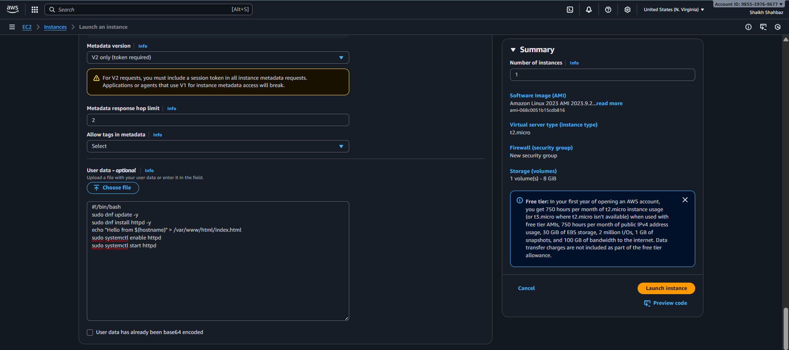
Step 3: Configure Private EC2 Instance
Fill details:
• Name: Private-EC2
• AMI: Amazon Linux 2023 AMI
• Instance Type: t2.micro
• Key Pair: Same (avengers.pem)
• Network: Production-VPC
• Subnet: Private-Subnet
• Auto-assign Public IP: Disable
• Security Group:
– Only allow SSH from Public-EC2 security group
– Allow HTTP if needed internally
Explanation:
Private instance will not receive a public IP and will use NAT for internet access.
Evidence: Screenshot of private instance network settings.
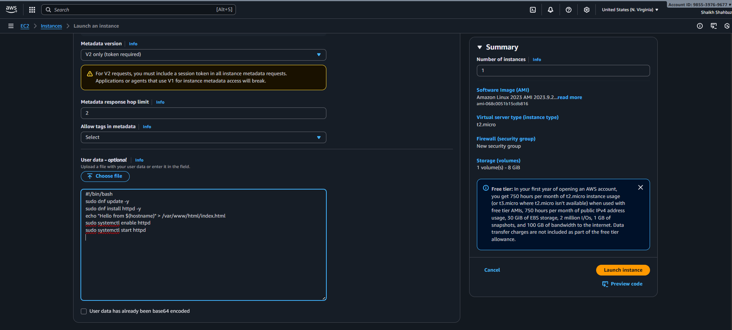
Step 4: Launch Both EC2 Instances
Click Launch Instance.
Explanation:
AWS provisions both EC2 instances into their respective subnets.
Evidence: Screenshot from “Instances → Running” showing both EC2s.
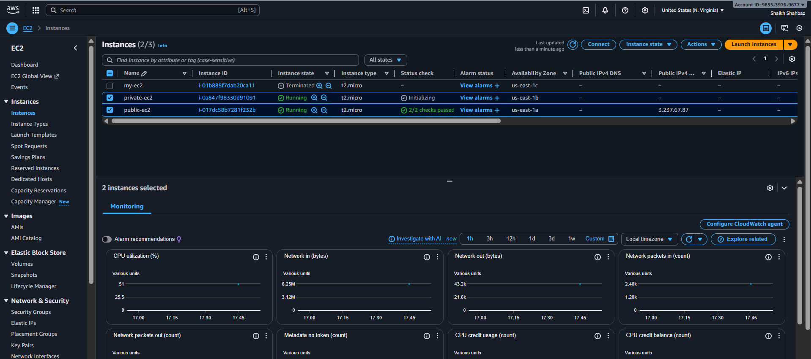
Step 5: Apply User Data to Install Apache
User data will be covered in next task, but here is the preview:
#!/bin/bash
sudo dnf update -y
sudo dnf install httpd -y
echo "Hello from $(hostname)" > /var/www/html/index.html
sudo systemctl enable httpd
sudo systemctl start httpd

Validation Steps (With Evidence)
Validation 1: Resource Health
Check instance status:
• Both instances = Running
• Status checks = 2/2 passed
Evidence: Screenshot from EC2 console.
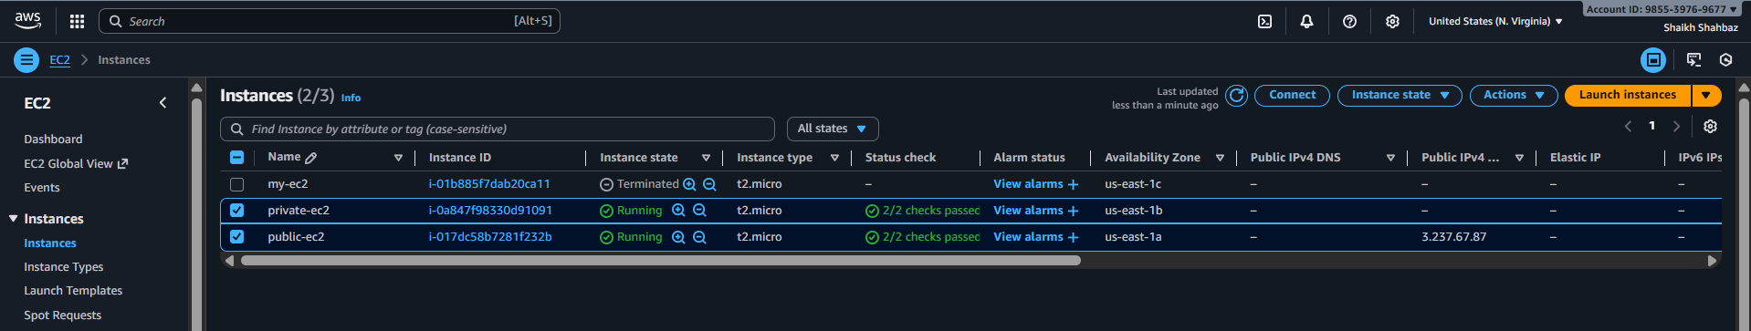
Validation 2: Functional Check
For Public EC2:
• Copy its public IP
• Open in browser → Should show test page
Evidence: Browser screenshot.
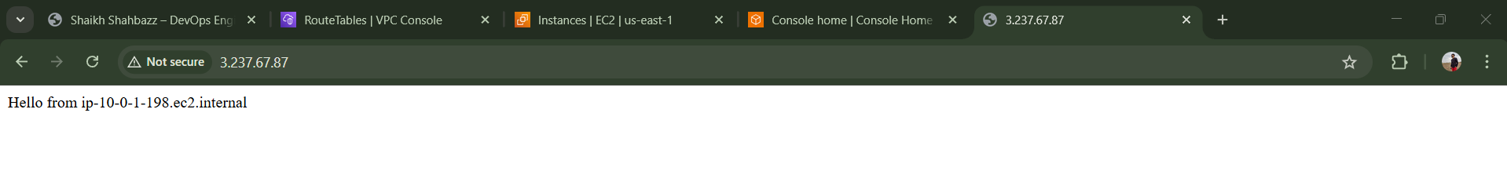
Issues Faced (Optional but Recommended)
• Public IP must be enabled for Public EC2.
• Incorrect security group rules may block SSH or HTTP.
• NAT Gateway must be ready for Private EC2 to reach internet.
Conclusion
Both public and private EC2 instances have been deployed successfully in their respective subnets. The public instance is internet reachable, while the private instance securely accesses the internet through the NAT Gateway.

- Deploy Apache server on both EC2 instances with a sample index.html file.

Task Title
Create Public and Private EC2 Instances in Separate Subnets
Objective
Deploy two EC2 instances:
- Public EC2 → accessible from the internet
- Private EC2 → accessible only via NAT/Bastion
These will later be used for Apache deployment and load balancing.
Prerequisites
- VPC already created
- Public subnet available
- Private subnet available
- Internet Gateway attached to VPC
- NAT Gateway created
- Route tables configured
- Key pair created (avengers.pem)
- Security groups created

Step-by-Step Implementation (With Evidence)
Step 1: Create Security Group for Public Instance
Console Path:
VPC → Security Groups → Create Security Group
Configuration:
- Name: sg-public-ec2
- VPC: Your VPC
- Inbound rules:
  - HTTP → 80 → 0.0.0.0/0
  - SSH → 22 → Your IP
Evidence:
(Attach screenshot in your documentation)
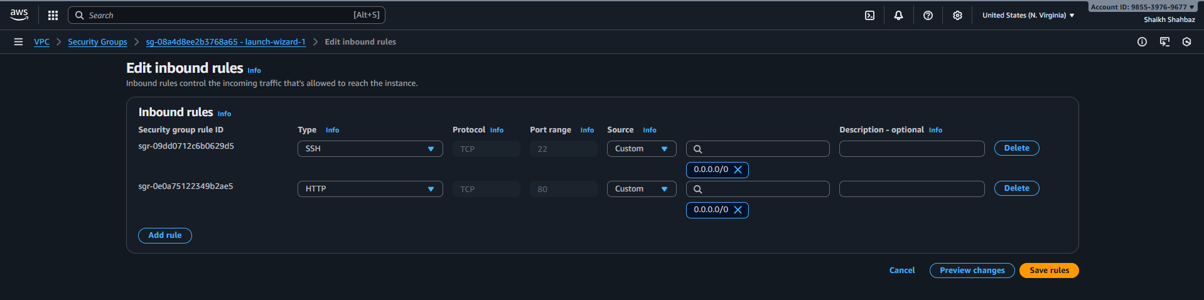
Step 2: Create Security Group for Private Instance
Console Path:
VPC → Security Groups → Create Security Group
Configuration:
- Name: sg-private-ec2
- VPC: Your VPC
- Inbound rules:
  - HTTP → 80 → sg-public-ec2 (for future ALB)
  - SSH → 22 → sg-public-ec2 (Bastion access)
Evidence:
(Attach screenshot)
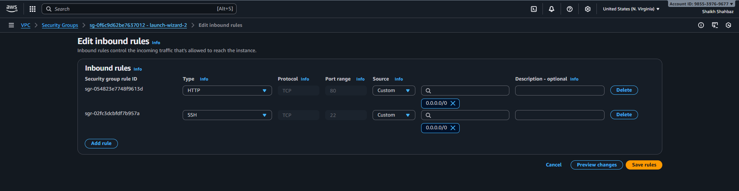
Step 3: Launch the Public EC2 Instance
Console Path:
EC2 → Instances → Launch Instance
Configuration:
- Name: Public-EC2
- AMI: Amazon Linux 2
- Instance Type: t2.micro
- Key Pair: Select your key
- Network:
  - VPC → Your VPC
  - Subnet → Public Subnet
  - Auto-assign Public IP → Enable
- Security Group: sg-public-ec2
User Data:
Evidence:
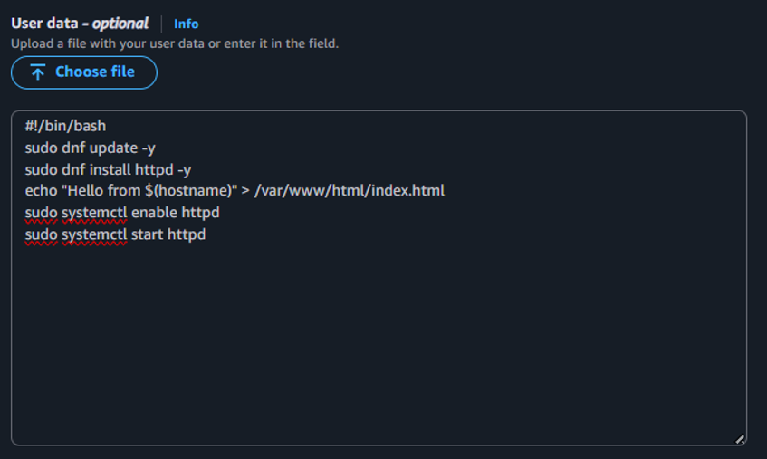
- Screenshot of launch summary
- Instance details


Step 4: Launch the Private EC2 Instance
Console Path:
EC2 → Instances → Launch Instance
Configuration:
- Name: Private-EC2
- AMI: Amazon Linux 2
- Instance Type: t2.micro
- Key Pair: Same as public instance
- Network:
  - VPC → Your VPC
  - Subnet → Private Subnet
  - Auto-assign Public IP → Disable
- Security Group: sg-private-ec2
Evidence:

User data:
Evidence:

- Screenshot of launch
- Instance details showing no public IP
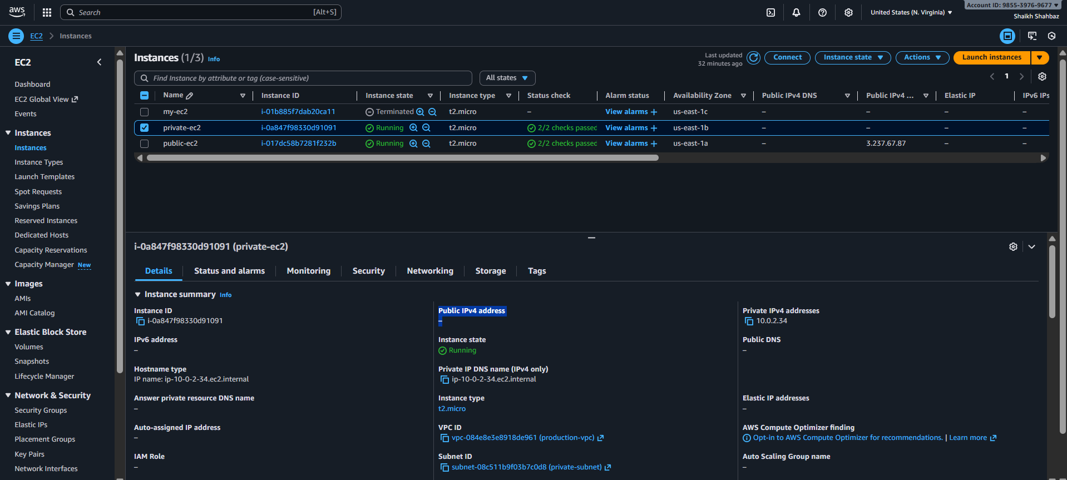
Validation Steps (With Evidence)
Validation 1: Public EC2 Has Public IP
- Check EC2 console → Public IPv4 address
Evidence: Attach screenshot
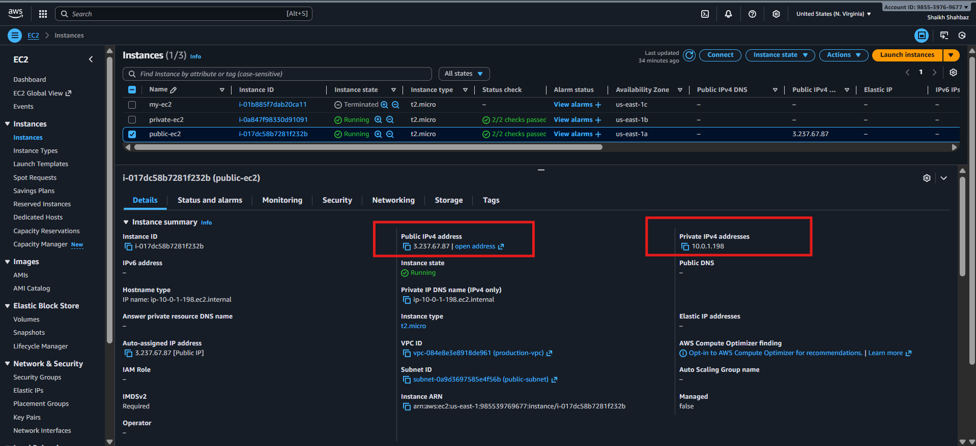
Validation 2: Private EC2 Has No Public IP
- Check EC2 console
Evidence: Private instance shows No Public IP
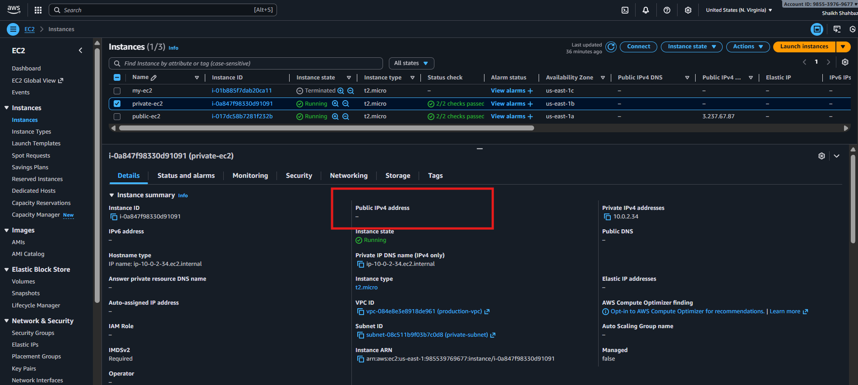
Issues Faced (Optional)
- If "Permission denied" occurs → security group inbound missing
- If Private EC2 can't access internet → check NAT Gateway & route tables
Conclusion
Both EC2 instances (public + private) are successfully deployed.
Private instance uses NAT for outbound internet; public instance is directly accessible.
- Create one application load balancer and attach it to both EC2 instances.
Task Title
Create an Application Load Balancer (ALB) and Register Both EC2 Instances
Objective
Deploy an Application Load Balancer that distributes incoming traffic to both EC2 instances (public + private) to ensure high availability and load distribution.
Prerequisites
- VPC created
- Public & private subnets
- EC2 instances running
- Apache installed on both EC2s
- Security group allowing HTTP (80)
- Internet-facing ALB requires:
• Two public subnets in different AZs
- Target group configuration

Step-by-Step Implementation (With Evidence)
Step 1: Create Security Group for ALB
Console Path:
VPC → Security Groups → Create security group
Rules:
- Inbound: HTTP (80) → 0.0.0.0/0
- Outbound: Allow All
Evidence
Insert screenshot of SG configuration
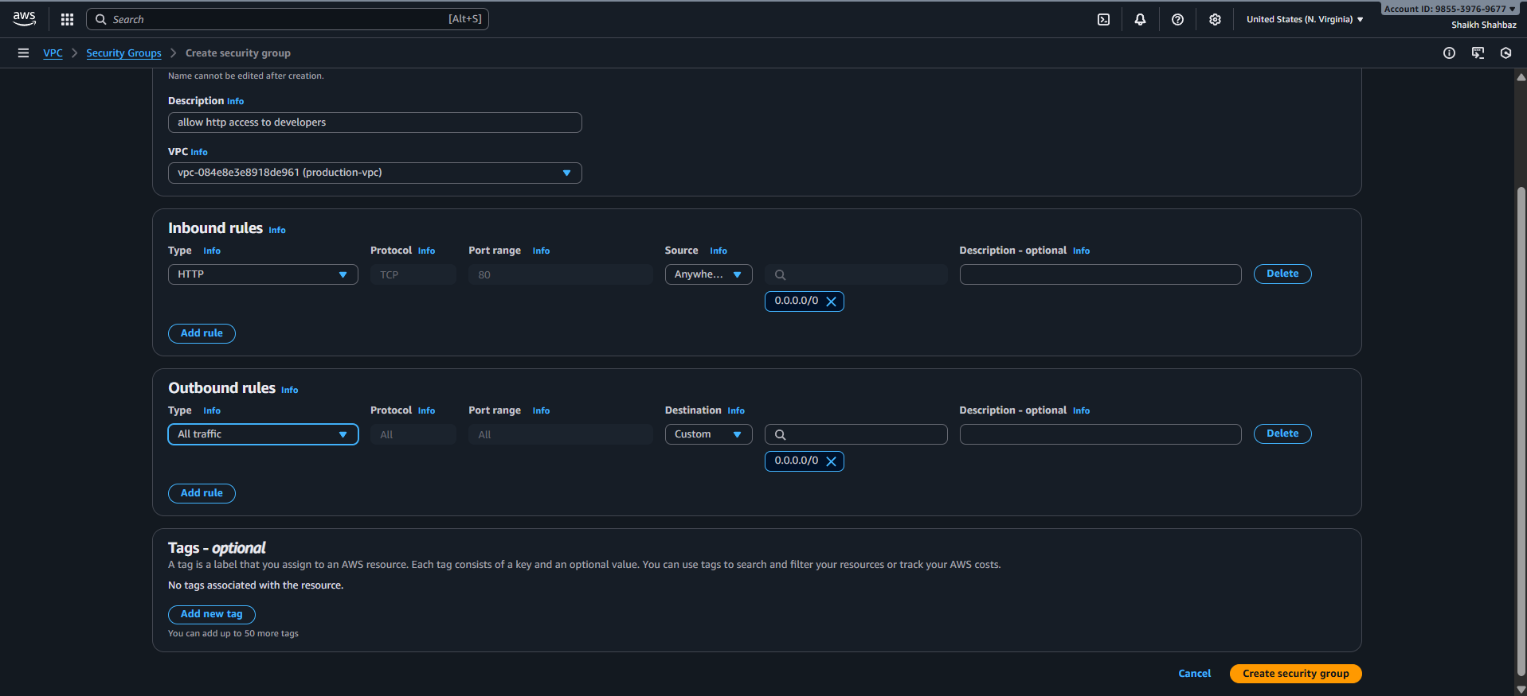
Step 2: Create Target Group
Console Path:
EC2 Dashboard → Load Balancing → Target Groups → Create target group
Settings:
- Target type: Instances
- Protocol: HTTP
- Port: 80
- Health Check:
  - Protocol: HTTP
  - Path: /
Register both EC2 instances:
- Public EC2
- Private EC2
Click Create
Evidence
Screenshot of registered targets (Healthy state)
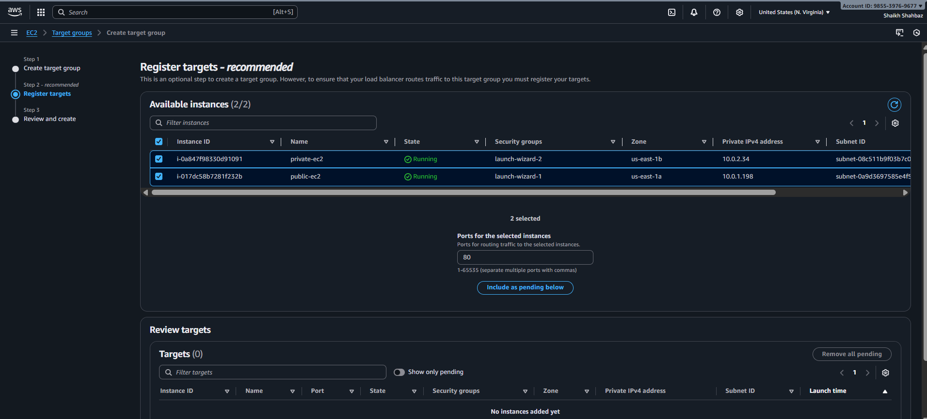
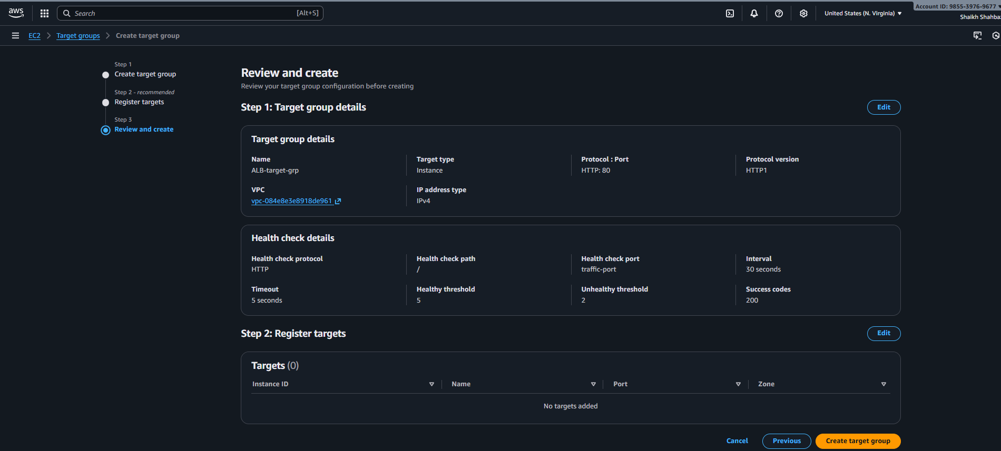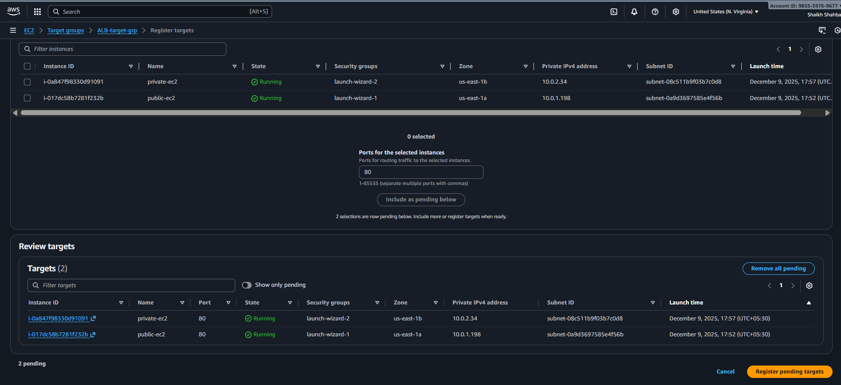
Step 3: Create Application Load Balancer
Console Path:
EC2 → Load Balancers → Create Load Balancer → Application Load Balancer
Fill details:
- Name: my-app-alb
- Scheme: Internet-facing
- IP type: IPv4
- VPC: Select your VPC
- Subnets: Select 2 public subnets
Assign ALB Security Group:
- Select the HTTP ALB security group created earlier
Listener:
- Protocol: HTTP
- Port: 80
- Forward to: Your target group
Click Create Load Balancer
Evidence
Insert screenshot of ALB creation & provisioning status
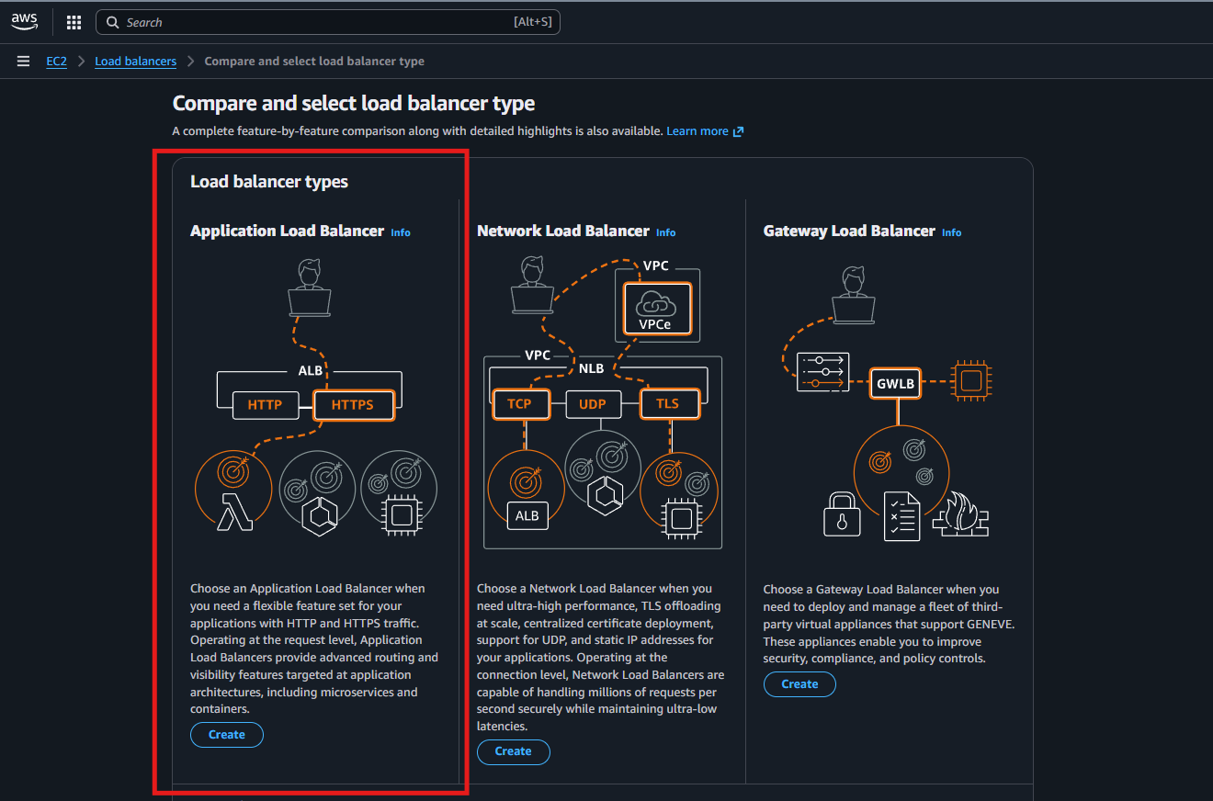
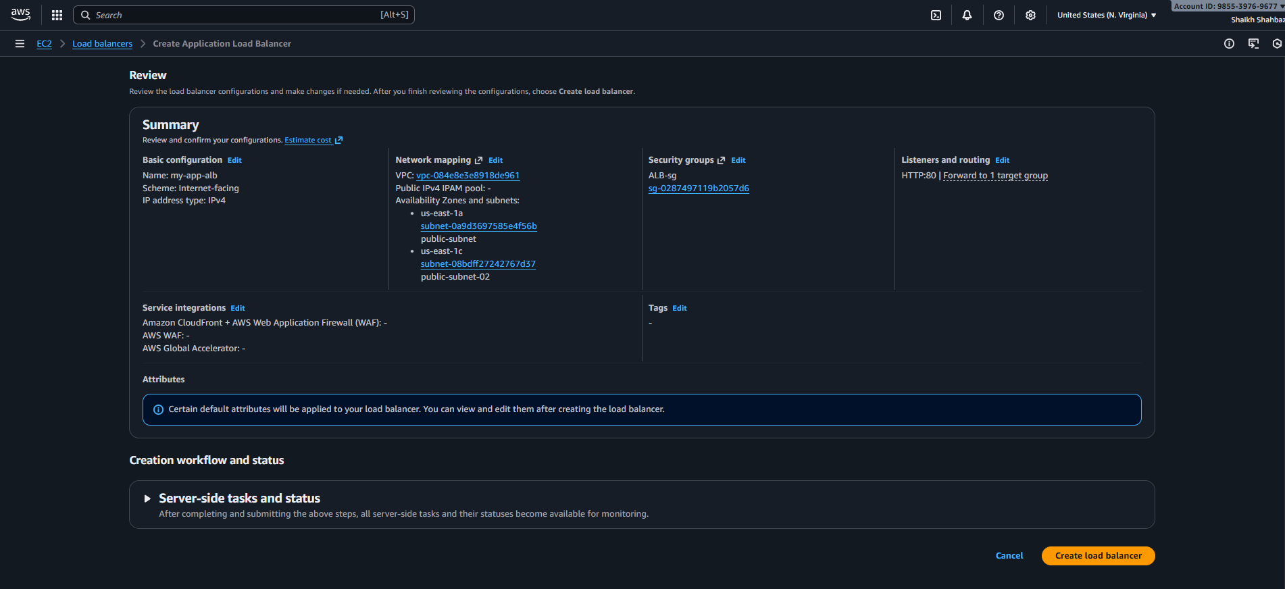
Step 4: Verify ALB Health Checks
Console Path:
EC2 → Target Groups → Select TG → Targets
Status must show:
- Healthy for both public & private EC2
Evidence
Screenshot of Healthy status
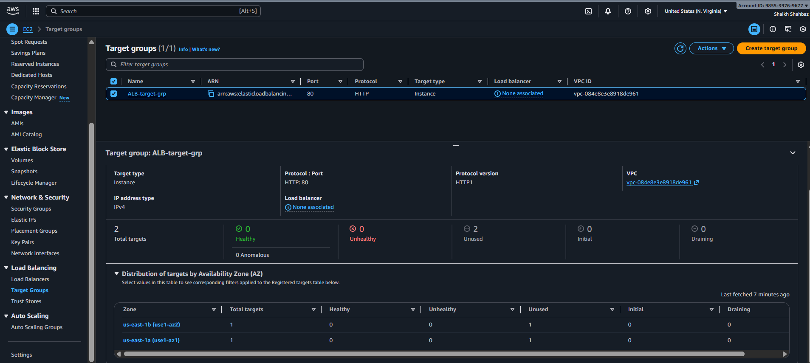
Step 5: Test ALB DNS Name
Output:
Find ALB DNS name:
<alb-name>-123456.region.elb.amazonaws.com
Open in browser:
http://<alb-dns-name>
You should see:
- Public EC2 page
- Private EC2 page (when load balancer distributes requests)
Refresh multiple times to see both pages.
Evidence
Browser screenshots showing:
- “This is Public EC2”
- “This is Private EC2”
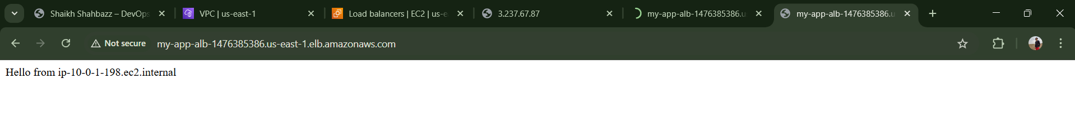
Validation Steps (With Evidence)
✔️ Validation 1: ALB Status
ALB state = Active
Evidence: Screenshot
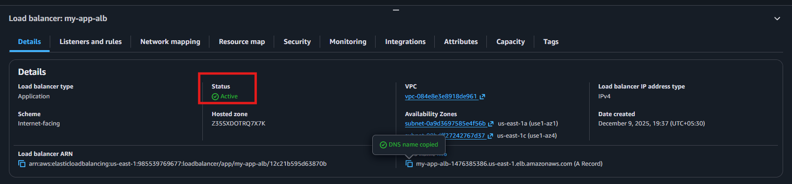
✔️ Validation 2: Targets Healthy
Both EC2 = Healthy
Evidence: Screenshot
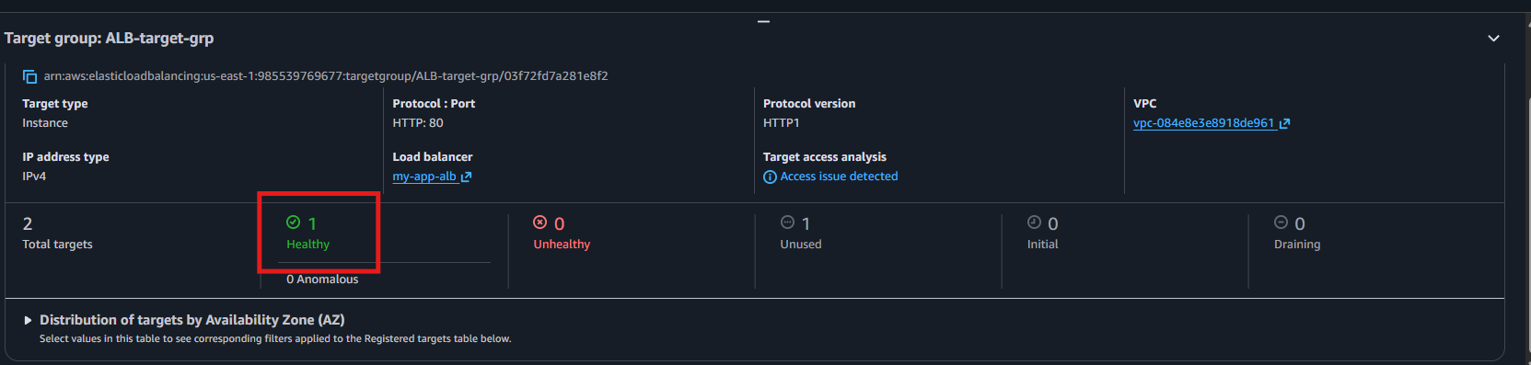
✔️ Validation 3: Functional Check
Browser loads the website via ALB DNS
Evidence: Screenshot

✔️ Validation 4: Load Distribution
Refreshing page alternates between public & private content
Evidence: Two screenshots showing different outputs
Issues Faced (Optional)
Issue 1: Targets Unhealthy
Fix:
- Ensure port 80 open on EC2 SG
- Apache must be running
- Health check path must be /
Issue 2: Private EC2 not reachable
Fix:
- Ensure private EC2 SG allows inbound HTTP from ALB SG
- Health checks must be allowed
Conclusion
Application Load Balancer successfully created and configured.
Traffic is now evenly routed between public and private EC2 instances, improving availability, scaling, and load distribution.

- Store application load balancer logs in S3.
Task Title
Enable ALB Access Logging to S3
Objective
Configure the Application Load Balancer to store access logs (requests, client IP, latency, target info) into an S3 bucket for auditing, troubleshooting, and compliance.
Prerequisites
- ALB already created and running
- EC2 instances registered & healthy
- S3 bucket created for log storage
- Bucket policy allowing ALB to write logs
- Correct region-specific logging prefix

Step-by-Step Implementation (With Evidence)
Step 1: Create S3 Bucket for ALB Logs
Console Path:
S3 → Create bucket
Configuration:
- Name: alb-access-logs-shahbaz
- Region: Same region as ALB (N. Virginia – us-east-1)
- Block Public Access: Enabled (recommended)
- Versioning: Optional
Click Create Bucket
Evidence:
Insert bucket creation screenshot
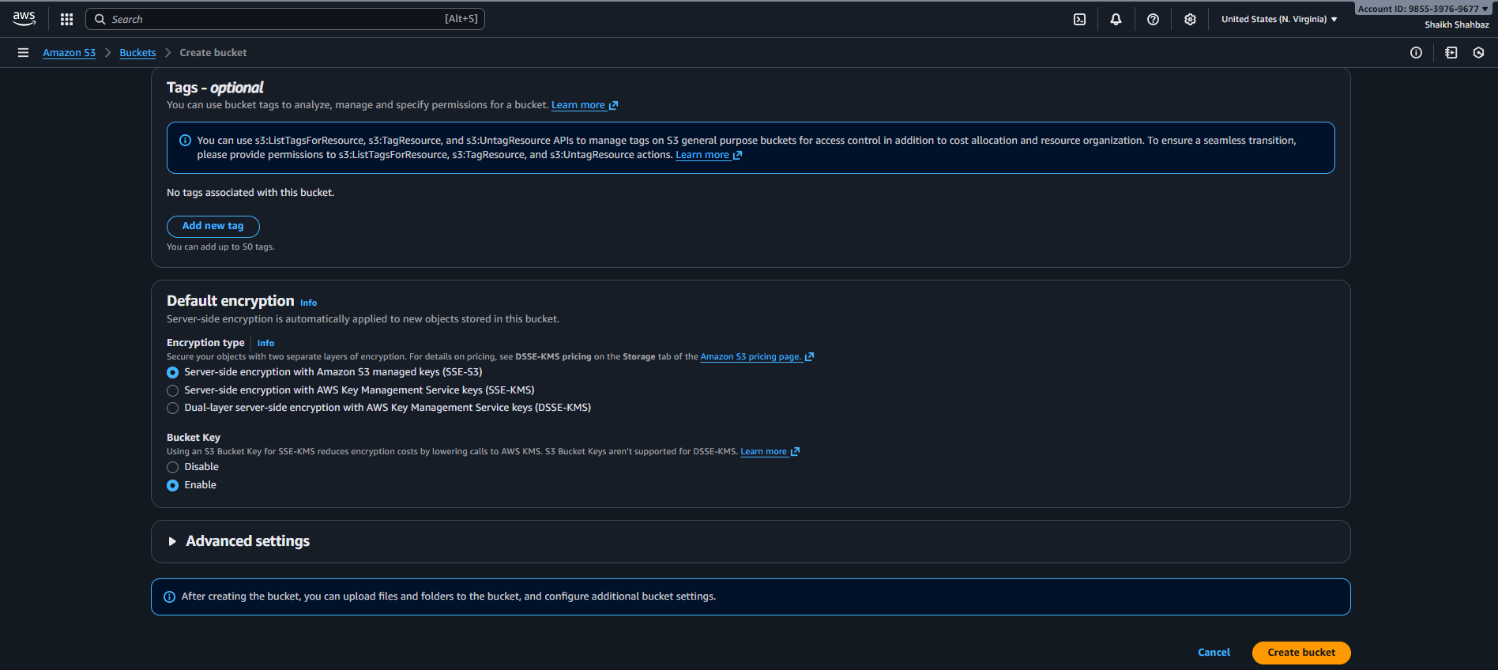
Step 2: Apply Required Bucket Policy for ALB Logging
Go to:
S3 → Bucket → Permissions → Bucket Policy
Evidence:
Screenshot of bucket policy applied
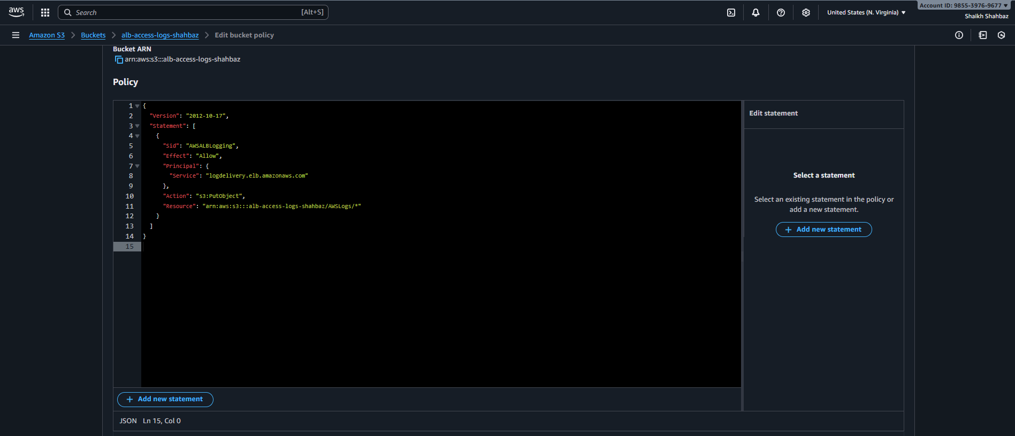
Step 3: Enable ALB Access Logging
Console Path:
EC2 → Load Balancers → Select ALB → Attributes tab
Under Access Logs:
- Turn ON
- Bucket name: alb-access-logs-shahbaz
- Prefix: ALB-logs/
Click Save
Evidence:
Screenshot of ALB attributes with Access Logs turned ON
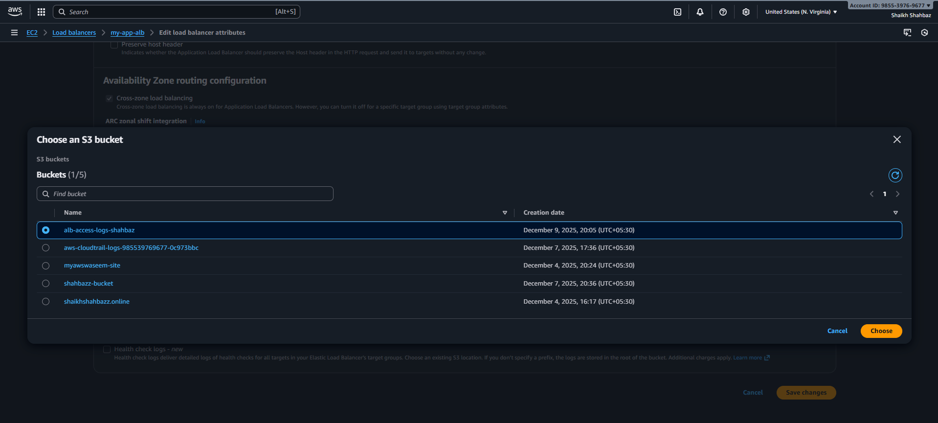
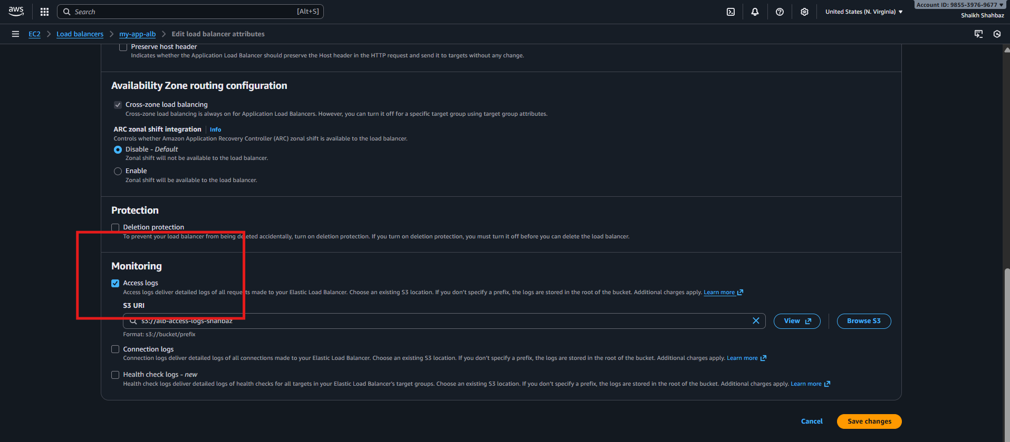
Step 4: Generate Traffic to ALB
Visit the ALB DNS name in browser repeatedly:
http://<alb-dns-name>
This generates log entries.
Evidence:
Screenshot of browser accessing ALB
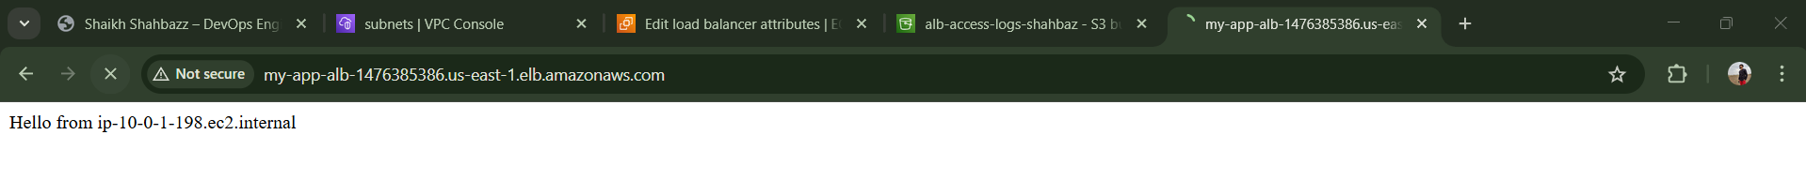
Step 5: Check Logs in S3
Console Path:
S3 → Bucket → ALB-logs folder
You should see folders:
- AWSLogs/
- ELB account ID/
- Year/Month/Day/
Inside the date folder, log files named like:
elasticloadbalancing_us-east-1_20250101T1200Z.log.gz
Evidence:
Screenshot of log objects inside S3
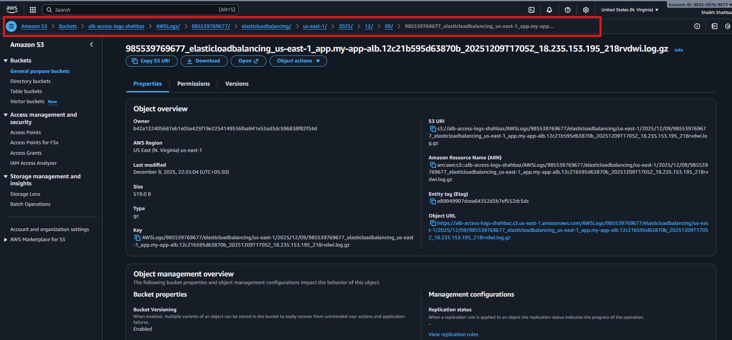
Validation Steps (With Evidence)
✔️ Validation 1: Bucket Exists
Evidence: S3 list screenshot
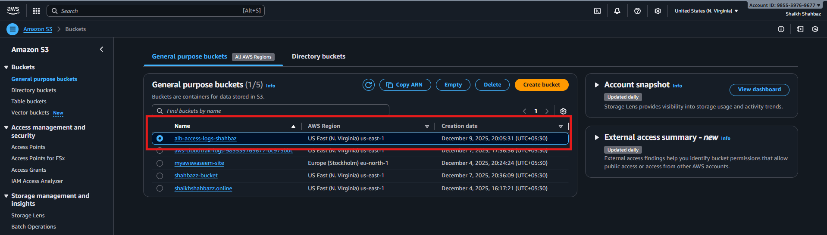
✔️ Validation 2: ALB Logging Enabled
Evidence: ALB “Access Logs: Enabled” screenshot
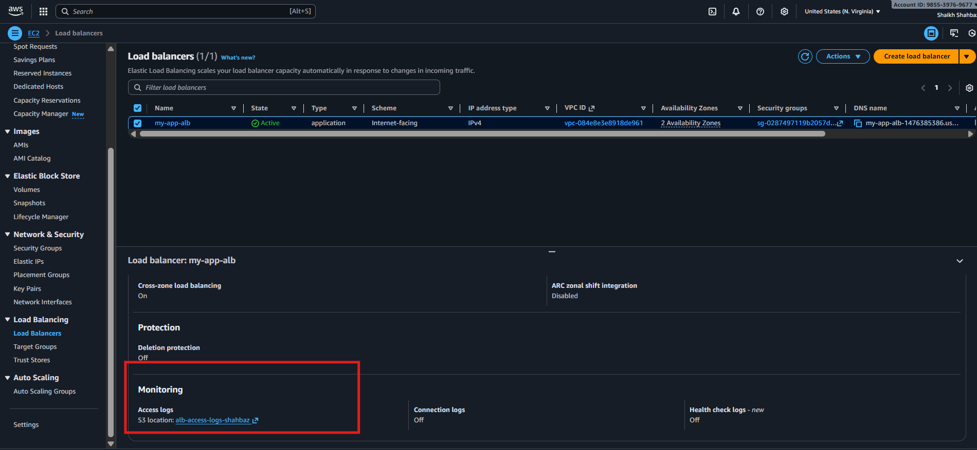
✔️ Validation 3: Log Files Created
Evidence: Screenshot of .gz log files in S3
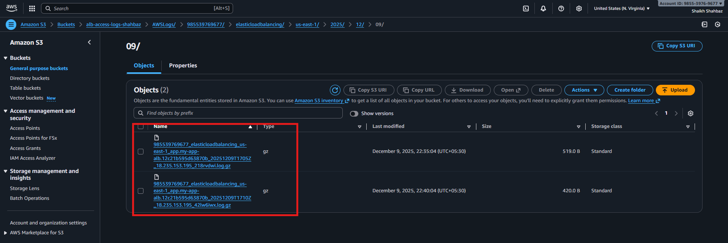
Issues Faced (Optional)
Issue 1: No logs generated
Fix: Ensure traffic hits the ALB (refresh browser 5–10 times)
Issue 2: S3 permission error
Fix: Bucket policy incorrect → ALB cannot write logs
Issue 3: Logs visible only after delay
ALB logs may take 5–10 minutes to appear
Conclusion
Application Load Balancer access logging successfully enabled with logs stored in S3 for auditing, troubleshooting, and compliance. This enables full visibility into traffic patterns and performance.

- Store the VPC flow logs in a CloudWatch log group.
Objective
Enable VPC Flow Logs to capture network traffic (accepted/denied) within the VPC and store them in CloudWatch Logs for monitoring and troubleshooting.
Prerequisites
✔ Existing AWS VPC
✔ Subnets configured (Public & Private)
✔ Security Groups applied to resources
✔ EC2 / ALB running to generate traffic
✔ IAM permissions to create roles & log groups
✔ Internet traffic or ALB traffic to log flows

Step-by-Step Implementation (With Evidence)
Step 1: Navigate to the Flow Logs Section
Console Path:
VPC → Your VPCs → Select VPC → Flow Logs tab → Create Flow Log
Explanation: This is where AWS records packet flow metadata for all ENIs inside the VPC.
Evidence: Screenshot of Flow Logs tab before creation
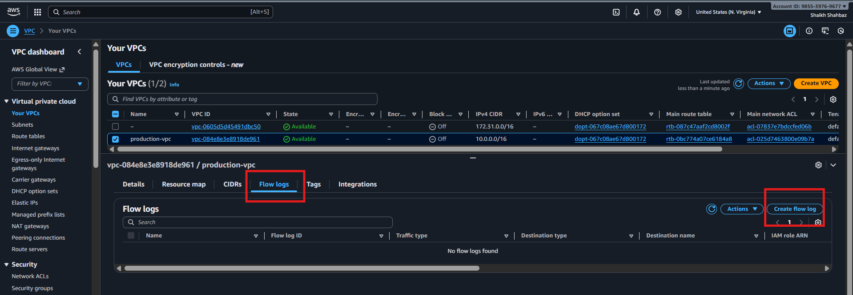
Step 2: Configure Flow Log Settings
Fill the details:
Field | Value
Filter | All
Maximum aggregation interval | 1 minute
Destination | Send to CloudWatch Logs
Log group | Create new → VPCFlowLogs
IAM Role | Create new role (auto-generated)
Evidence: Screenshot of the Create flow log configuration page
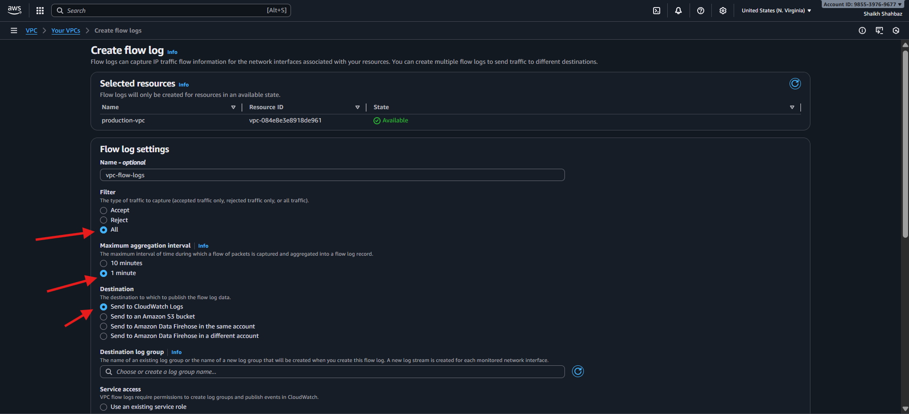
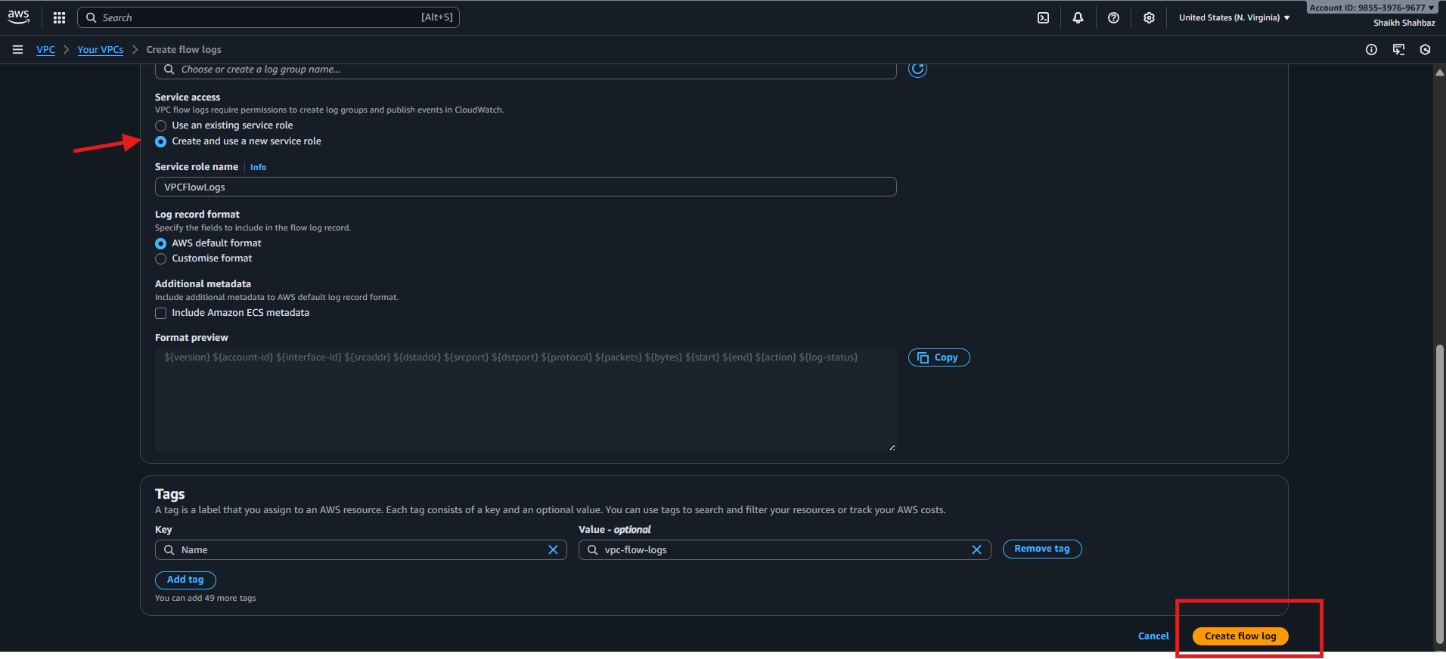
Explanation:
This enables logging of both allowed and denied traffic, and sends logs to CloudWatch Log Group with correct access policies.
Step 3: Confirm Flow Log Creation
Click Create, then verify:
- Status: Active
- Destination: CloudWatch Logs – VPCFlowLogs
Evidence: Screenshot of Flow Logs tab showing Active status
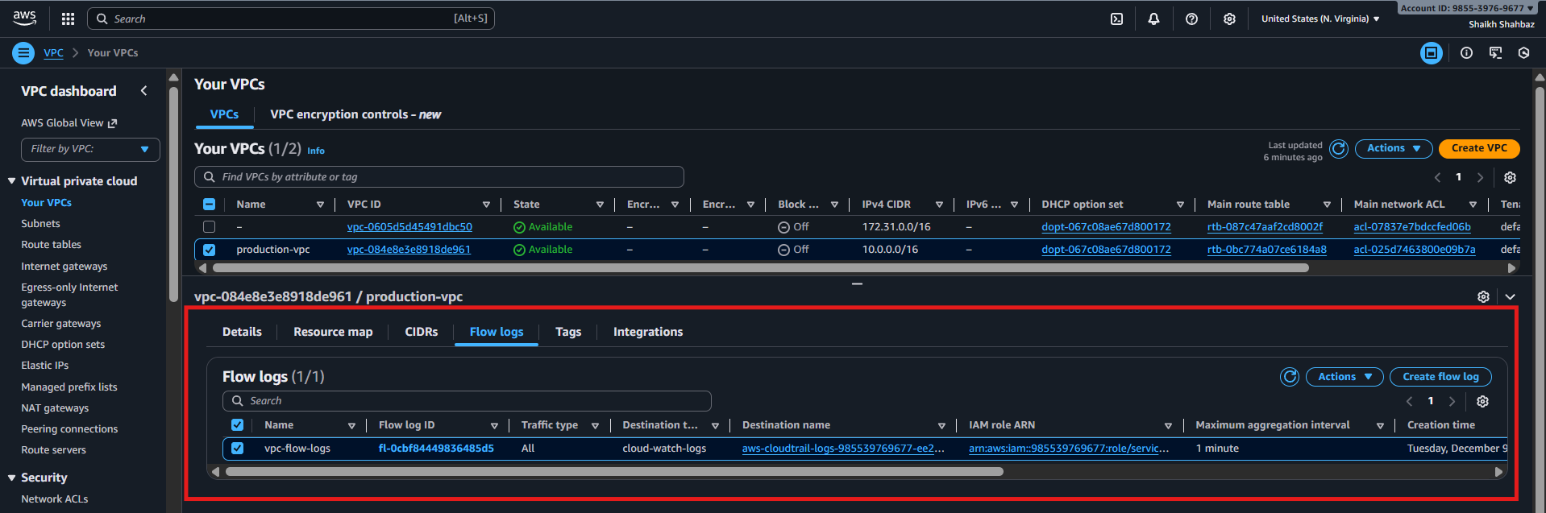
Step 4: Generate Network Traffic
- Open application endpoints (ALB public DNS or EC2 public IP)
- Refresh multiple times
OR
SSH to private instance and run:
ping google.com
curl amazon.com
Evidence: Terminal/browser screenshots showing outbound traffic
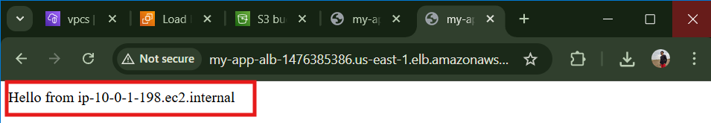
Step 5: Validate CloudWatch Log Group
Console Path:
CloudWatch → Logs → Log groups → VPCFlowLogs
- Open Log Group
- Select latest Log Stream
- Confirm log entries are visible:
- version account-id interface-id srcaddr dstaddr sport dport protocol packets bytes action log-status
Evidence: Screenshot of the Log Stream containing log records

Validation steps :
1.Validation :
Flow logs status
Expected result : Flow log status = active in vpc console
Evidence required : Screenshot
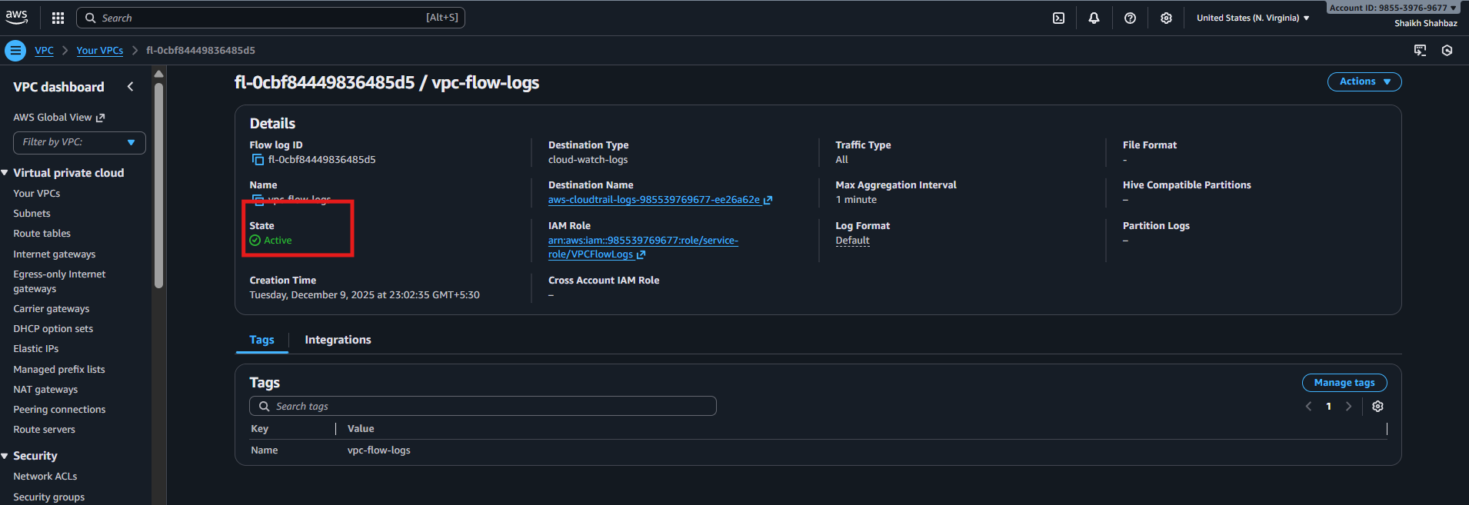
2.Validation :
Logs Generated
Expected result : Log entries visible in CloudWatch Log Group
Evidence required : Screenshot of log stream
Issues Faced (Optional)
- Sometimes Flow Log status remains Error due to missing IAM Role permissions
🔹 Fix: Ensure role has logs:CreateLogStream & logs:PutLogEvents
- Logs not visible?
🔹 Wait 3–10 minutes after enabling
🔹 Ensure traffic is generated
Conclusion
VPC Flow Logs were successfully enabled and verified. Network flow metadata is stored in CloudWatch Logs and can now be used for monitoring, troubleshooting, and security analysis.

- Create monitoring dashboards to monitor CPU utilization and to monitor the Apache service.
Objective
Create a CloudWatch Monitoring Dashboard to visually track:
- EC2 instance CPU utilization
- Apache HTTP server service availability
Prerequisites
- EC2 instance running Apache Web Server
- CloudWatch Agent installed and configured on EC2 (required for service monitoring)
- IAM role attached to EC2 with CloudWatch permissions
- Security Group allows HTTP (Port 80)
- Apache service actively running

Step-by-Step Implementation (With Evidence)
Step 1: Open CloudWatch Dashboard Section
Go to:
CloudWatch → Dashboards → Create dashboard
Provide a dashboard name:
WebServer-Monitoring
(Capture a screenshot as Evidence)
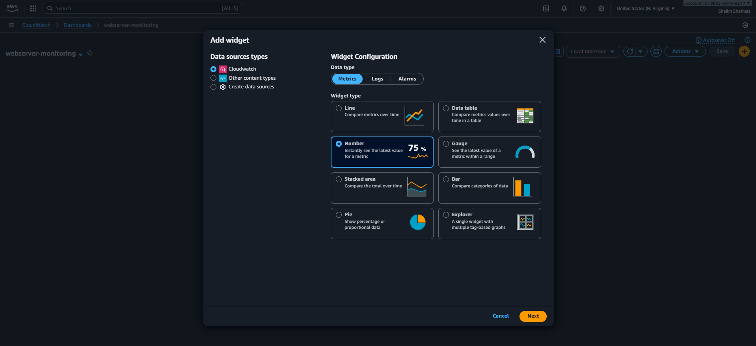
Step 2: Add CPU Utilization Monitoring
Inside the dashboard, choose:
Add widget → Number → Configure
Select metric path:
EC2 → Per-Instance Metrics → CPUUtilization
Select your EC2 instance
This displays real-time CPU performance.
(CPU graph as Evidence)
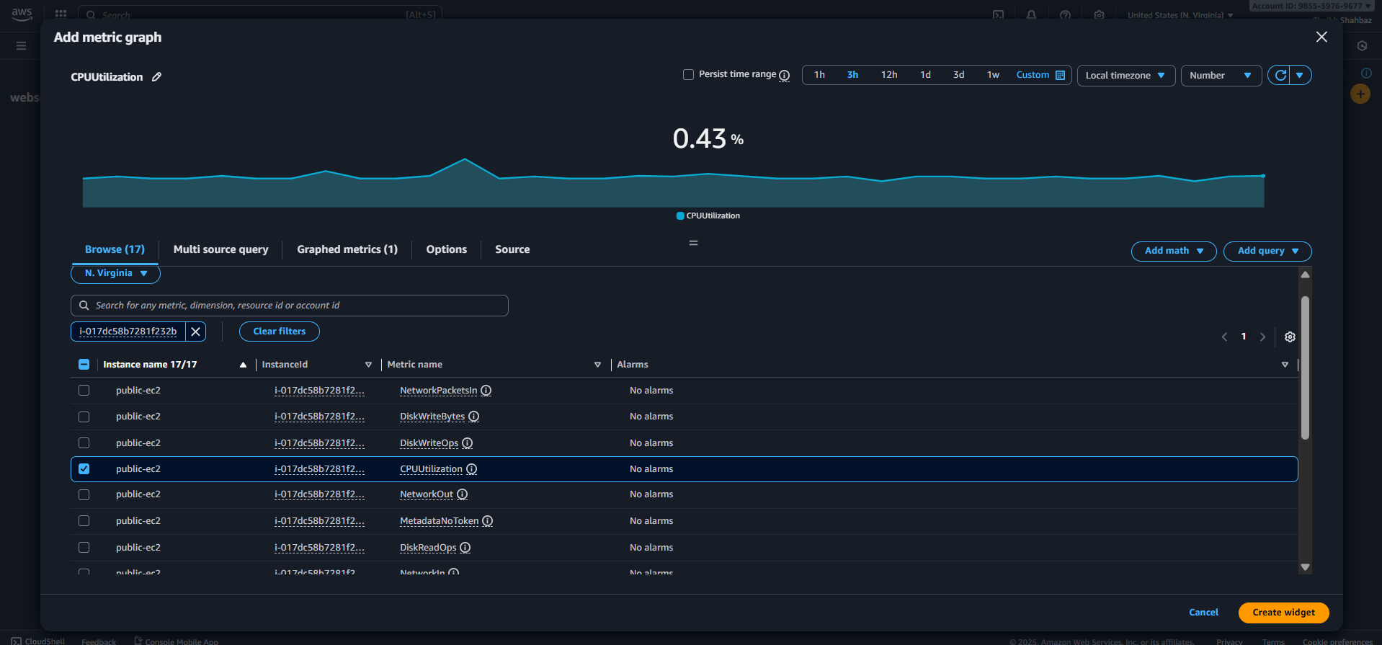
Step 3: Add Apache Service Monitoring Widget
Click:
Add widget → Number widget → Metrics → CWAgent
Open the path:
Enable the path : sudo vi /opt/aws/amazon-cloudwatch-agent/etc/amazon-cloudwatch-agent.json
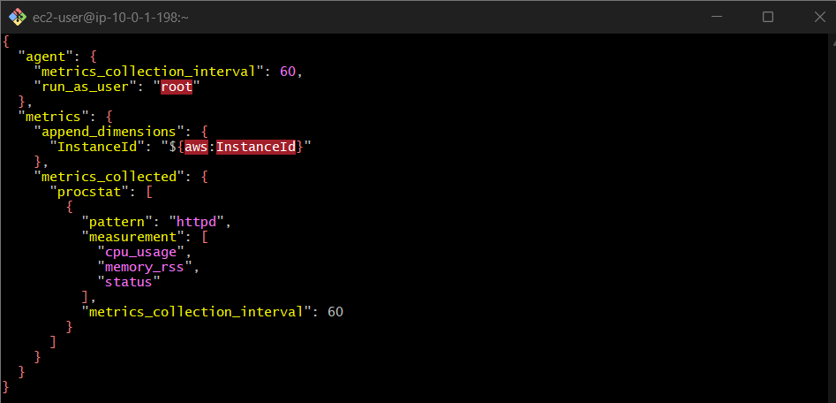
CWAgent → procstat → Status
Choose the metric showing Apache service:
On Amazon Linux/RHEL: procstat_status{name="httpd"}
A value of 1 means Apache is running
A value of 0 means Apache is stopped/faulted
Step 4: Arrange and Save Dashboard
- Rename the widgets to meaningful names:
  - CPU Utilization
  - Apache Service Status
- Change period to 1 minute for better visibility
- Save dashboard layout
(Insert full dashboard screenshot as Evidence)
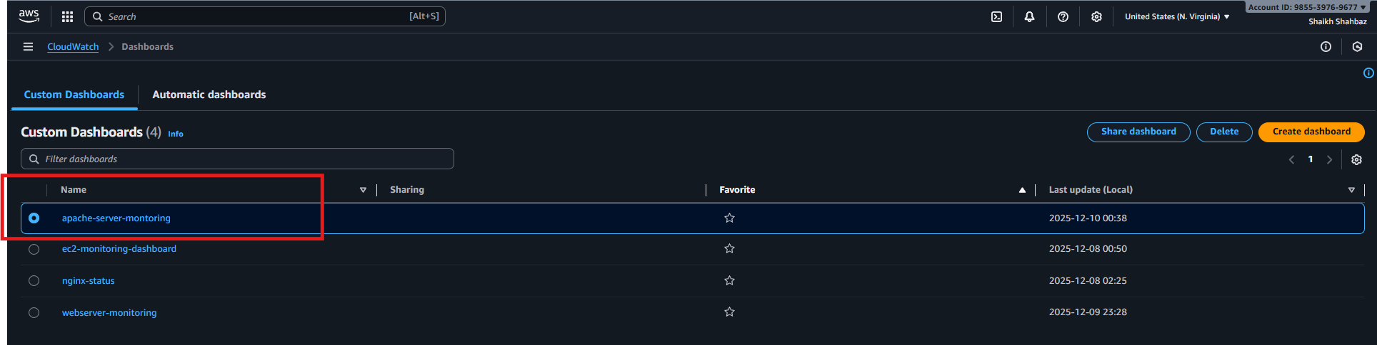
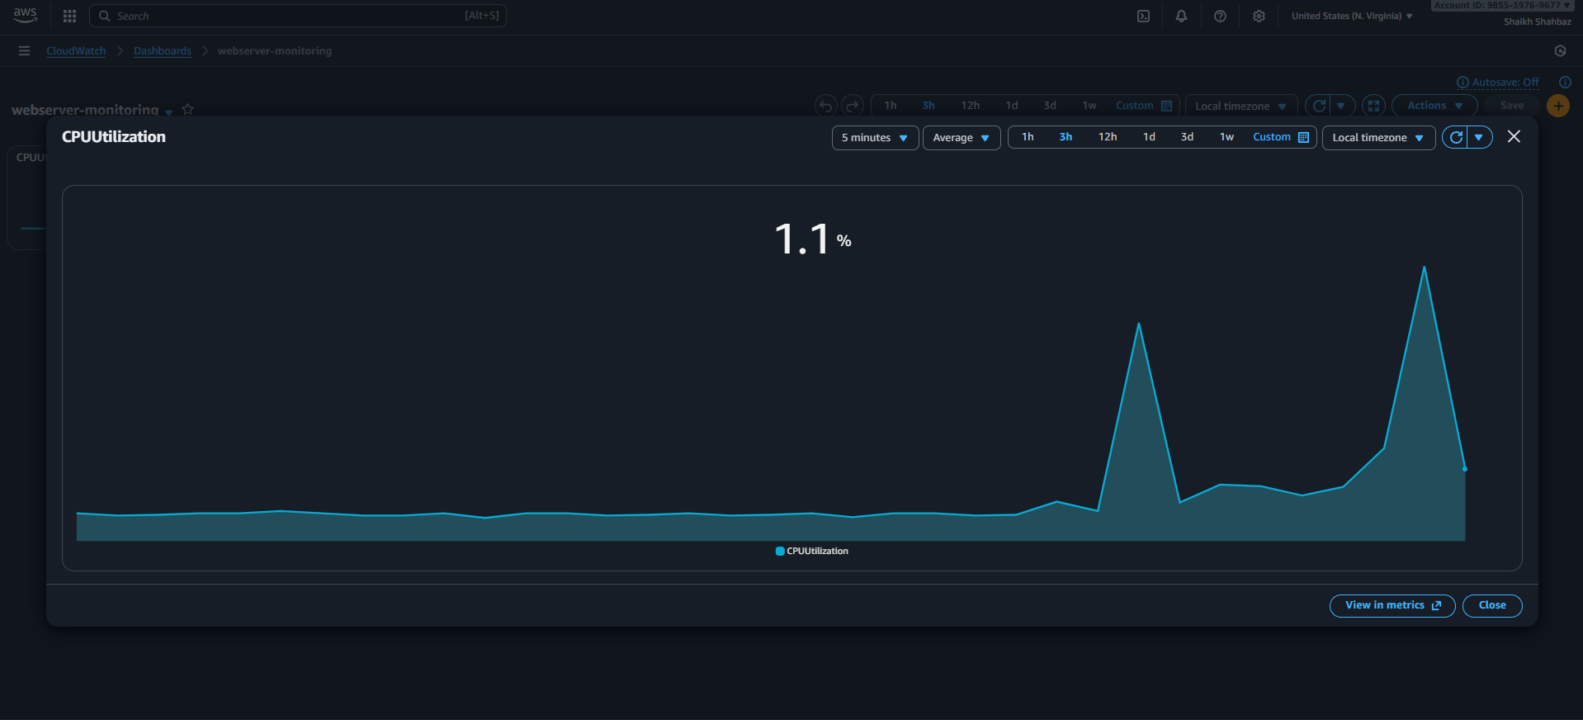
Validation Steps (Mandatory With Evidence)
Validation 1: Dashboard Status
Confirm the new dashboard appears under:
CloudWatch → Dashboards
(Provide screenshot)

Validation 2: CPU Graph Working
CPU utilization graph must show ongoing metric changes
(Provide screenshot)
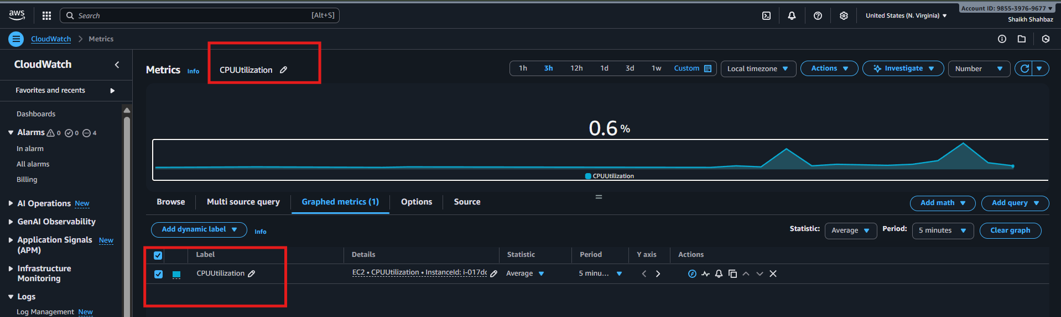

Issues Faced (Optional)
If Apache widget shows no data → CloudWatch Agent not installed or misconfigured
If CPU metrics not visible → incorrect instance selected or no traffic
If metrics delay → wait 2-3 minutes for updates
Conclusion
CloudWatch dashboard successfully created.
CPU utilization and Apache service status are now monitored visually in real-time to support operational awareness and troubleshooting.

- If CPU utilization is more than 70%, then it should trigger auto scaling and launch new instance.
Task Title
Auto Scale EC2 Instances When CPU Utilization Exceeds 70%
Objective
Automatically launch additional EC2 instances when CPU utilization goes above 70% using an Auto Scaling Group (ASG) and CloudWatch alarms.
Prerequisites
• VPC
• Public and/or Private Subnets
• IAM Role for EC2
• Key Pair
• Security Groups
• Launch Template or AMI
• CloudWatch Alarm permissions
• Auto Scaling Group

Step-by-Step Implementation (With Evidence)
Step 1: Create a Launch Template
Console Path:
EC2 → Launch Templates → Create Launch Template
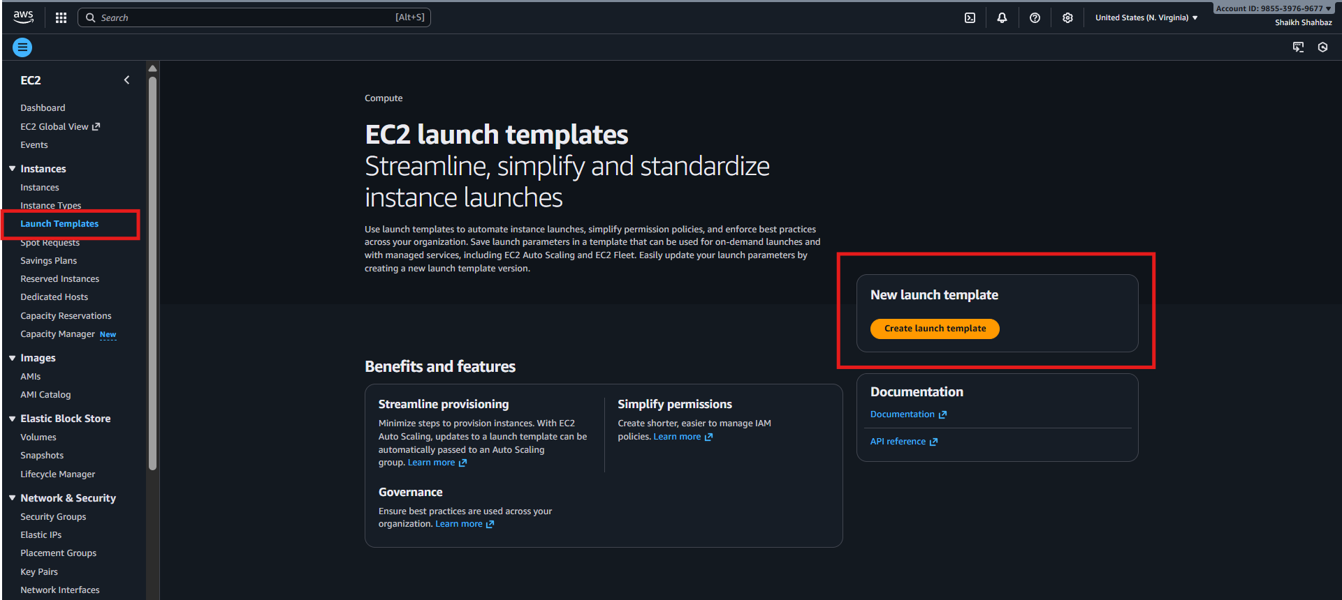
Template Must Include:
• AMI
• Instance Type
• IAM Role
• Security Group
• Key Pair
Evidence:
• Screenshot: Launch template created
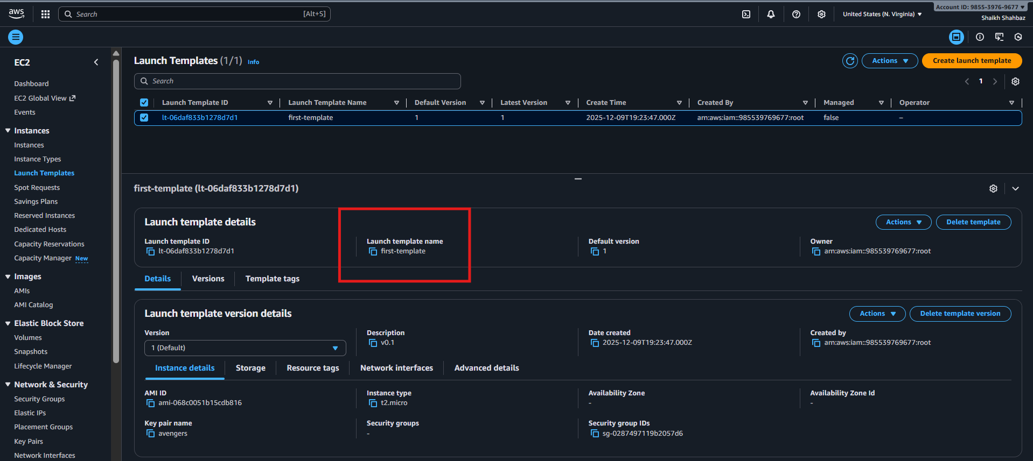
Step 2: Create an Auto Scaling Group (ASG)
Console Path:
EC2 → Auto Scaling Groups → Create ASG
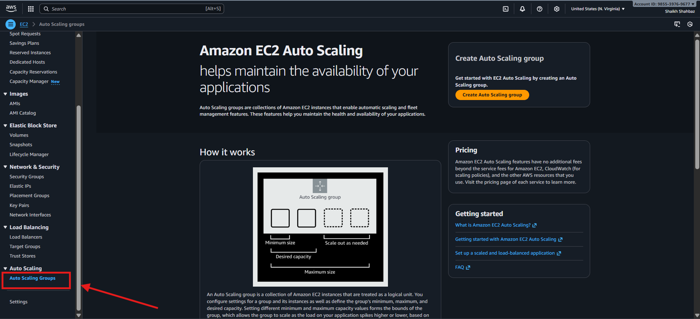
Configuration:
• Launch Template: my-asg-template
• VPC Subnets: Select required subnets
• Min size: 1
• Desired capacity: 2
• Max size: 5
Evidence:
• Screenshot: ASG created and shows 1 instance running
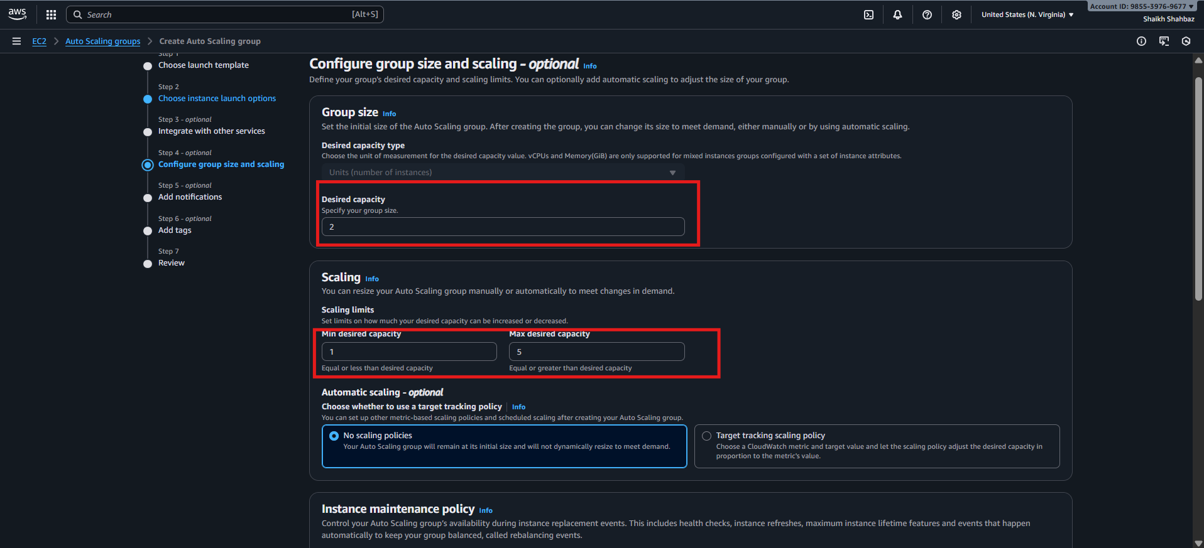
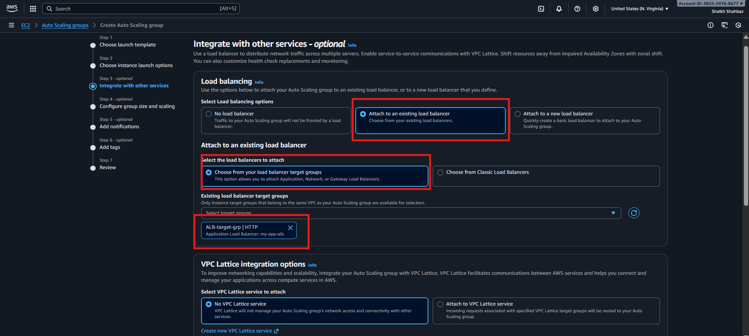
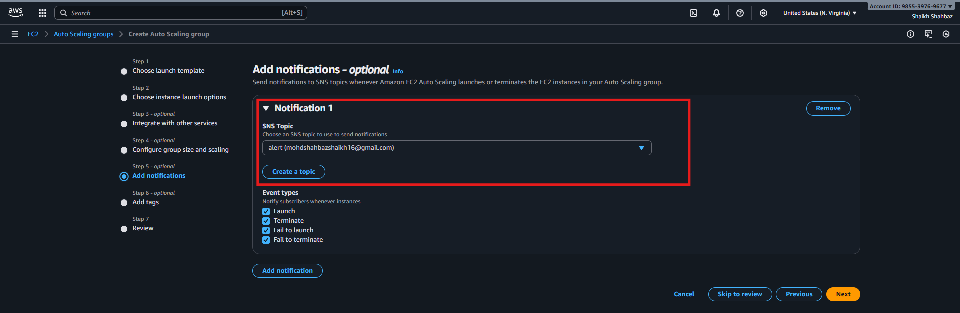
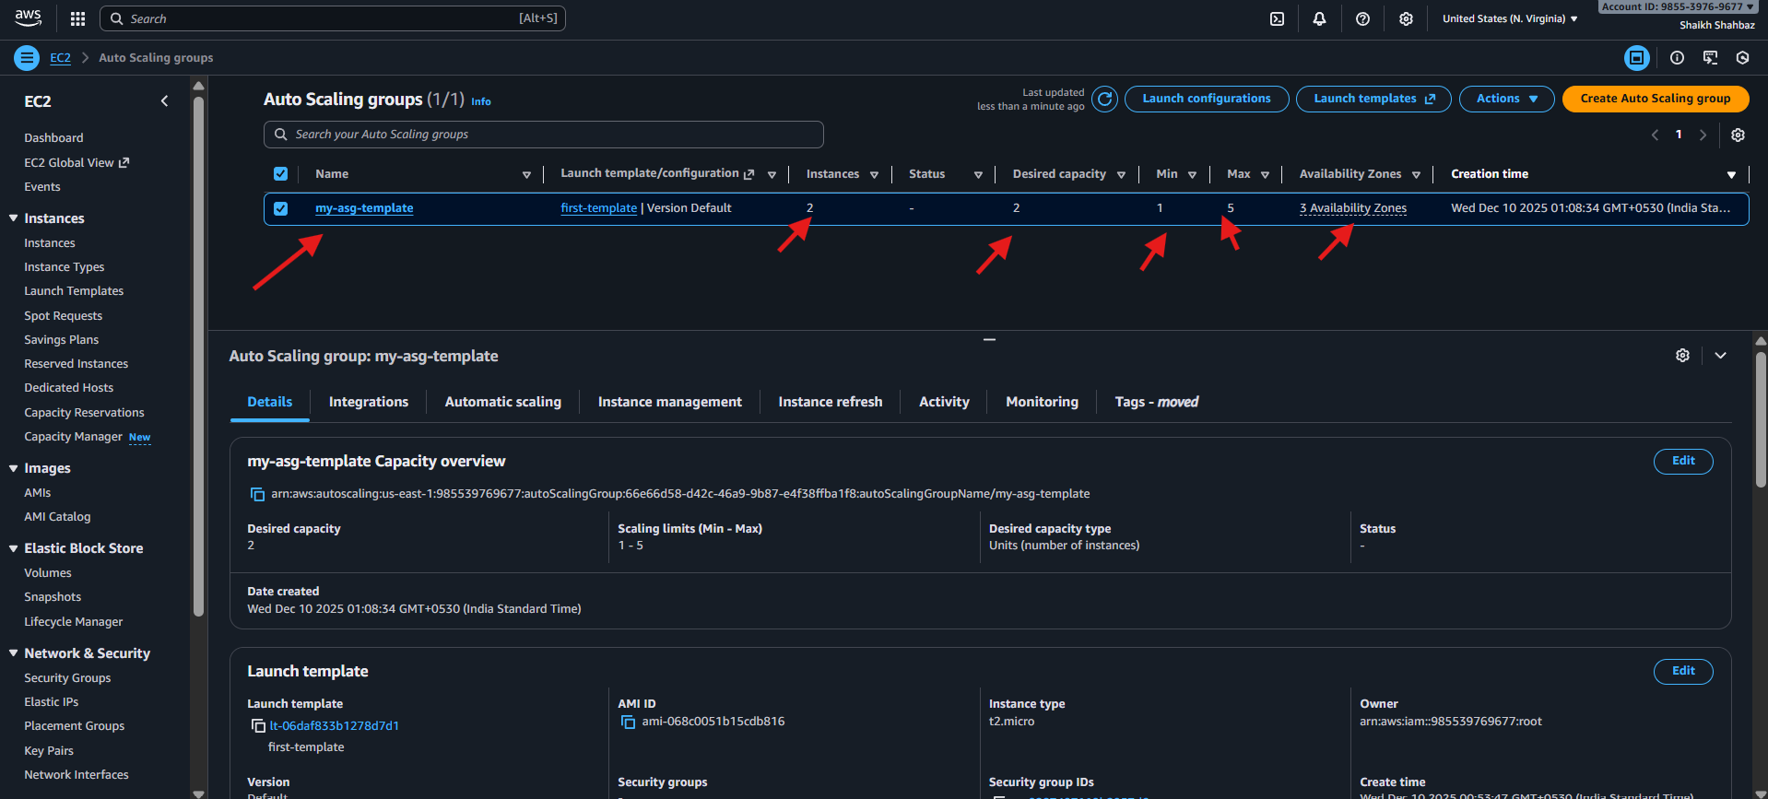
Step 3: Create a Scaling Policy (Scale Out Policy)
Console Path:
ASG → Automatic Scaling → Add Policy → Step Scaling or Simple Scaling
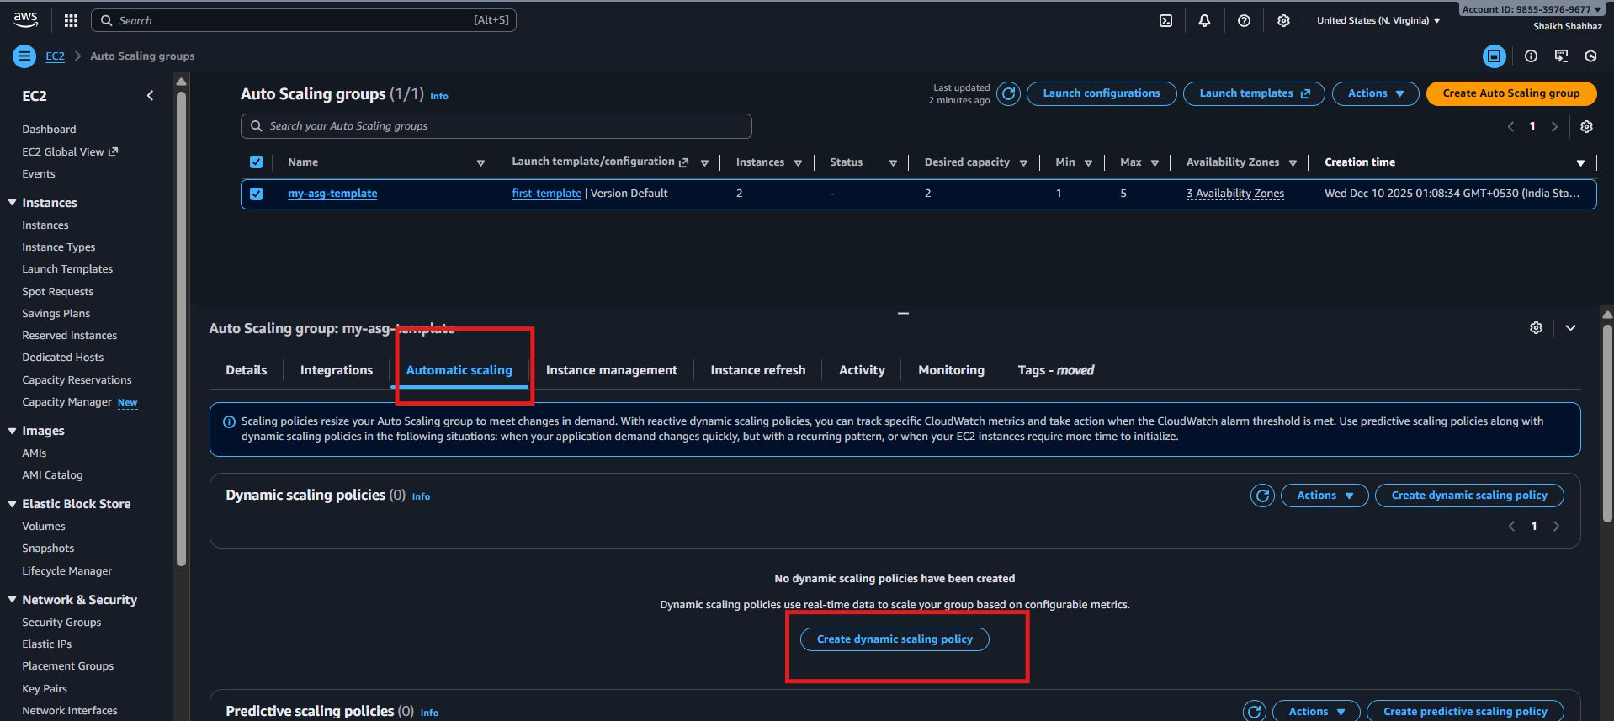
This returns a policy ARN.
Evidence:
• Scaling Policy ARN
• Console screenshot of Scaling Policies
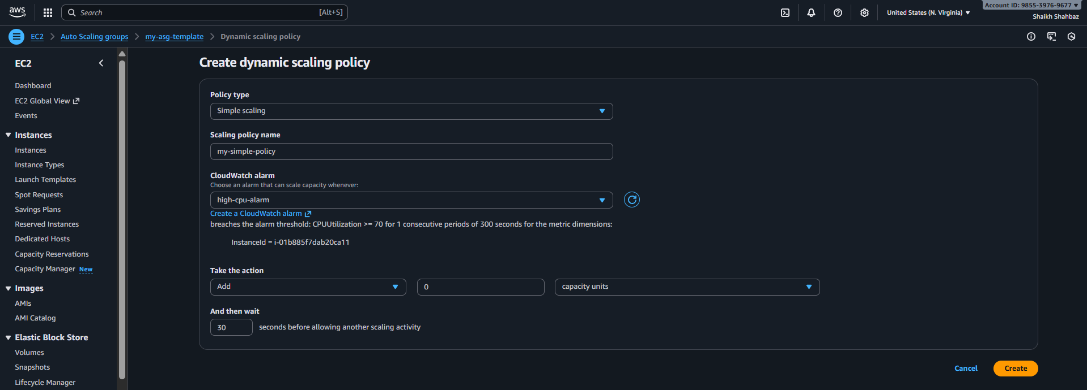
Step 4: Create CloudWatch Alarm for CPU > 70%
This alarm triggers the scale-out policy created above.
Console Path:
CloudWatch → Alarms → Create Alarm → EC2 → CPUUtilization
Configuration:
• Metric: CPUUtilization
• Threshold: Greater than 70%
• Evaluation period: 2 × 1 minute
• Alarm action: Select your scale-out policy ARN
Evidence:
• CloudWatch Alarm in “ALARM” state screenshot
• Policy attached correctly screenshot
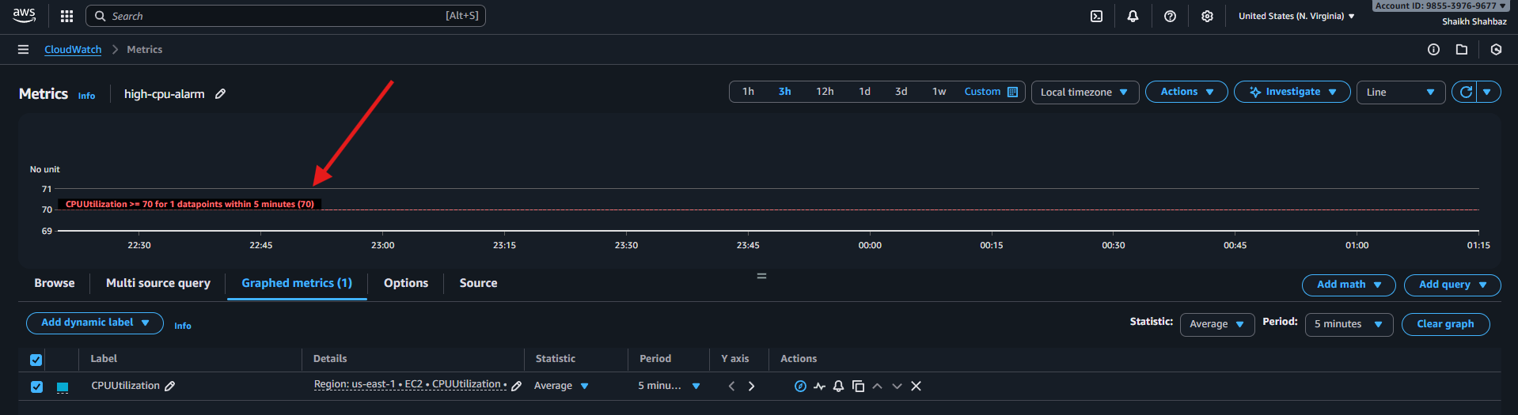
Step 5: Stress Test the Instance (To Trigger Scaling)
SSH into the EC2 and install stress tool.
sudo yum install stress -y
Run CPU load:
stress --cpu 8 --timeout 300
Evidence:
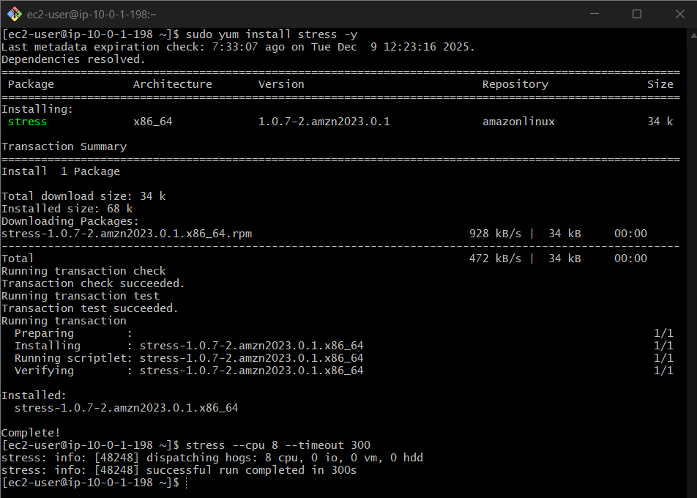
• Terminal output showing CPU stress
• CloudWatch graph shows CPU > 70%
• ASG activity log showing scale-out event
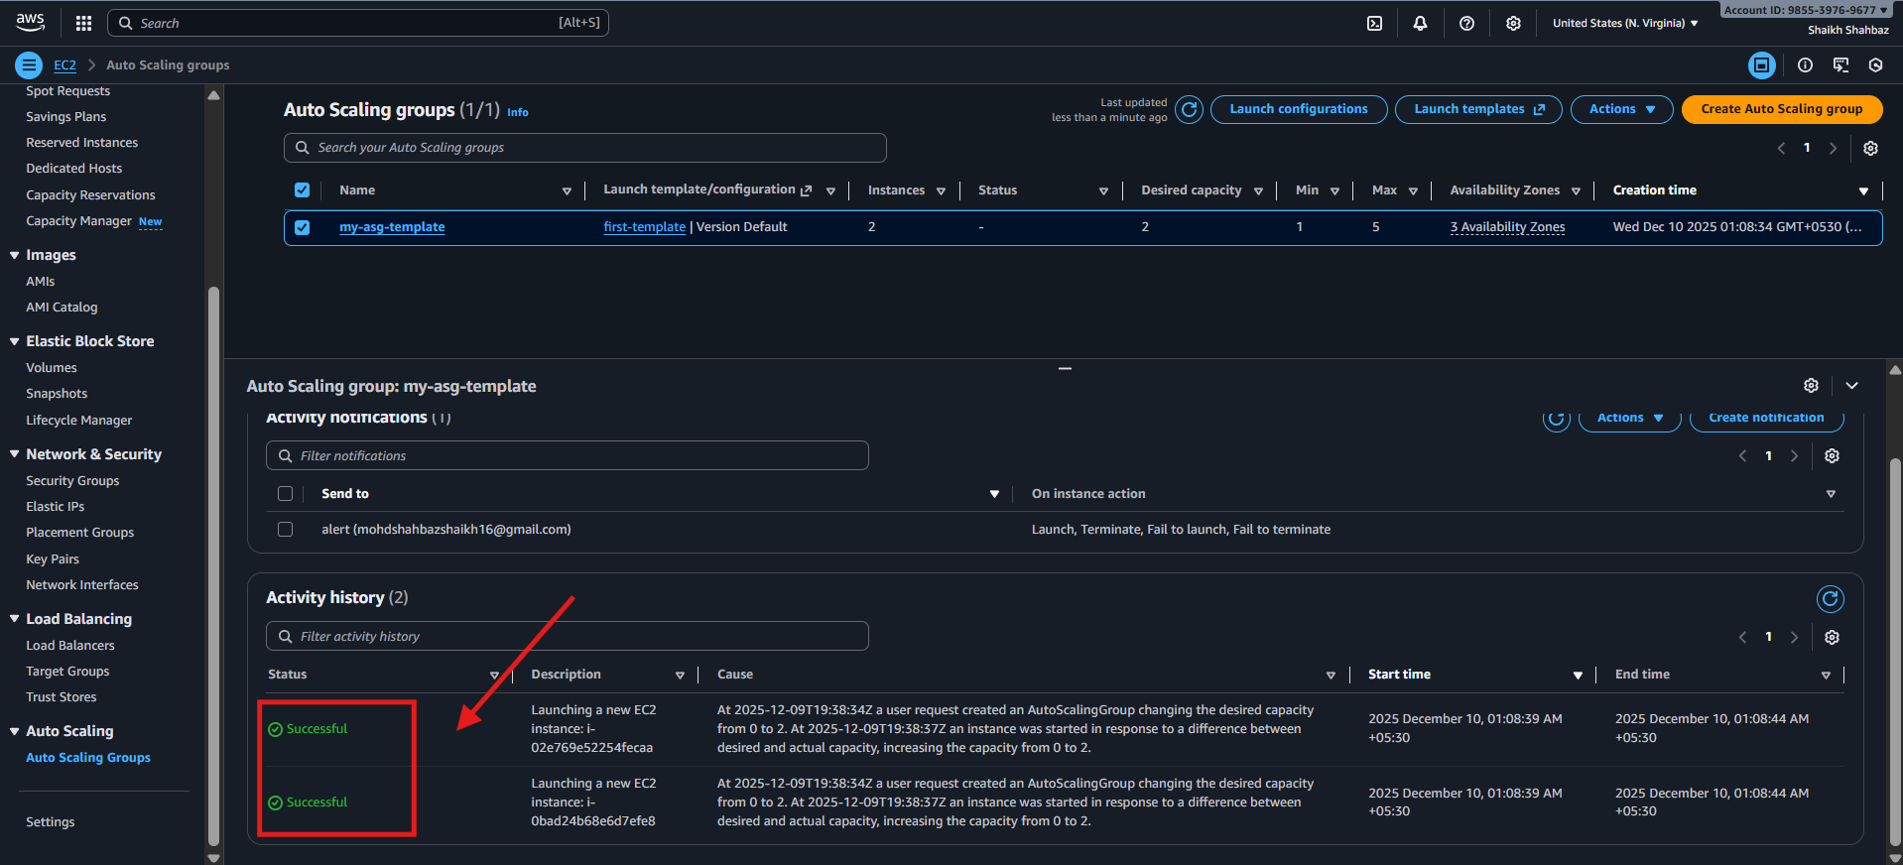
Validation Steps (Mandatory, With Evidence)
Validation 1: ASG Launched Additional Instance
Check:
ASG → Instances
Expected: Instance count increases from 1 → 2.
Evidence: Screenshot of 2 running instances.

Validation 2: CloudWatch Alarm Triggered
Check:
CloudWatch → Alarms
Expected: Alarm is in ALARM state.
Evidence: Alarm screenshot.
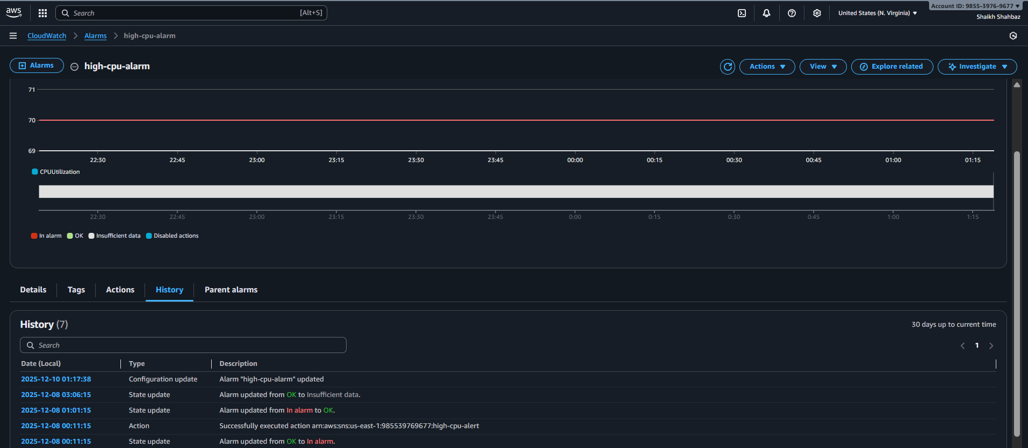
Validation 3: Scaling Activity Logs
Check: aws autoscaling describe-scaling-activities --auto-scaling-group-name my-asg
Expected: Activity shows "Launching a new EC2 instance"
Evidence.

Validation 4: New EC2 Instance Health
Check:
EC2 → Instances
Expected: Instance Status Check = 2/2 passed
Evidence: Instance screenshot.
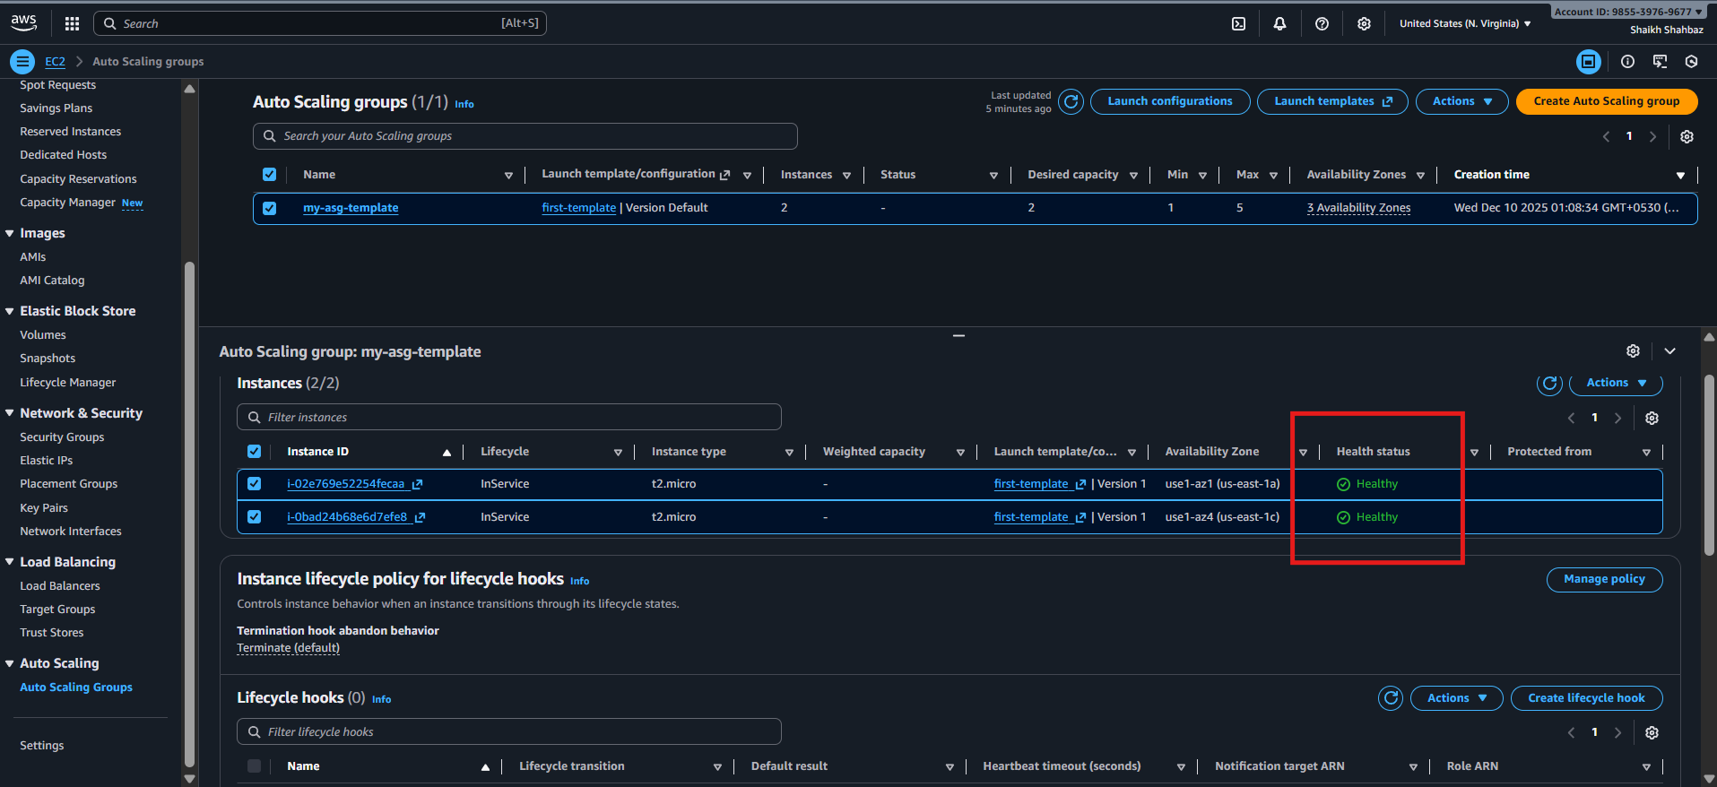
Issues Faced
- CloudWatch alarm not triggering
Fix: Lower threshold to test (e.g., 10%)
- ASG not launching new instance
Fix: Check IAM permissions, subnet availability, launch template
Conclusion:
The Auto Scaling Group successfully launches new EC2 instances when CPU utilization exceeds 70%, ensuring scalability and high availability.

